LAMPIRAN 1
ALAT UKUR

INFORM CONSENT
Salam sejahtera! Saya Rizky Ardi Purnama S.Psi., mahasiswa MM (Magister Manajemen) UBAYA (Universitas Surabaya), sedang dalam proses penyusunan TESIS terkait pengalaman konsumsi di restoran Mc. Donald's di Surabaya. Mohon bantuan Anda untuk membagikan pengalaman KONSUMSI Anda dengan menjawab beberapa pertanyaan dan pernyataan di bawah ini sesuai dengan keadaan dan pengalaman Anda masing - masing dengan sebenar - benarnya. Data yang Anda berikan akan kami jamin KERAHASIAAN-nya dan hanya diperuntukan untuk kepentingan penelitian. Atas kesediaan, pengertian, dan kerjasamanya, Saya ucapkan Terima Kasih!

Email Adress*

__________________________________________________________________

Saya dengan pengertian dan kesadaran penuh bersedia untuk memberikan keterangan dan informasi yang diminta dengan sebenar - benarnya, penuh tanggung jawab dan tanpa paksaan
Bersedia
Tidak Bersedia

Apakah Anda dalam satu bulan terakhir pernah makan (melakukan proses konsumsi) di restoran McD yang ada di Surabaya?
Pernah
Tidak Pernah

Dalam satu bulan terakhir seberapa sering Anda melakukan proses konsumsi di restoran ini?
1 Bulan 1 kali
2 hingga 3 kali
4 hingga 6 kali
>6 kali

IDENTITAS DIRI
Nama

Jenis Kelamin
Laki - Laki
Perempuan

Usia
15-25 tahun
26-35 tahun
>35 tahun
Pendidikan terakhir
SD
SMP
SMA
D3
S1
S2
S3

VARIABEL SSOS (Substantive Staging of Servicescape)
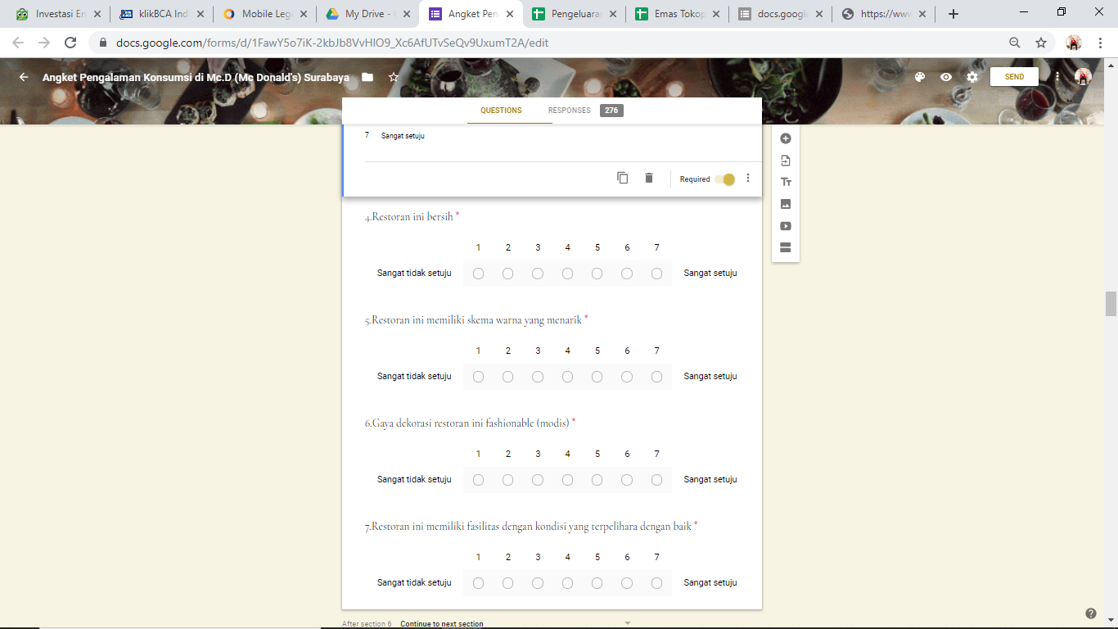
1. Latar belakang musik yang diputar membuat Anda nyaman

2. Restoran ini memiliki tema ruangan yang menarik

3.Atmosfer ruangan di restoran ini menyenangkan

4.Restoran ini bersih

5.Restoran ini memiliki skema warna yang menarik

6.Gaya dekorasi restoran ini fashionable (modis)

7.Restoran ini memiliki fasilitas dengan kondisi yang terpelihara dengan baik

VARIABEL CSOS (Commnicative Staging of Servicescape)
1.Anda bisa mencari kesamaan diri dengan karyawan di restoran ini.

2.Anda memiliki kemiripan dengan karyawan di restoran.

3.Para karyawan di restoran ini tidak ada bedanya dengan Anda.

4.Para karyawan di restoran ini berasal dari latar belakang yang mirip dengan Anda.

5.Anda merasa cocok dengan para karyawan di restoran ini.

6.Anda menyukai penampilan karyawan di restoran ini.

7.Para karyawan di restoran ini berpakaian dengan gaya yang wajar/ semestinya

8.Penampilan para karyawan sedap dipandang.

9.Para karyawan restoran ini ramah terhadap Anda.

10.Para karyawan restoran ini berperilaku baik.

11.Perilaku karyawan restoran ini menyenangkan.

12.Restoran ini menyampaikan budaya fast food ala amerika kepada Anda

VARIABEL EMOTION
1.Pengalaman konsumsi Anda di restoran ini menyenangkan.

2.Restoran ini membuat Anda merasa segar.

3.Restoran ini membangkitkan rasa antusias Anda.

4.Restoran ini membuat Anda merasa sangat bersemangat.

VARIABEL SATISFACTION
1.Secara keseluruhan, Anda puas dengan pengalaman konsumsi di restoran ini

2.Secara keseluruhan, Anda benar-benar menikmati diri Anda selama berada di restoran ini.

3.Keputusan Anda untuk pergi ke restoran ini adalah keputusan yang bijaksana.

VARIABEL SWB (SUBJECTIVE WELL BEING)
1.Secara umum, Anda menganggap diri Anda adalah orang yang sangat bahagia setelah mengunjungi restoran ini.

2.Anda menganggap diri Anda lebih bahagia dari sebagian besar teman-teman Anda, setelah mengunjungi restoran ini

3.Anda umumnya sangat menikmati hidup setelah mengunjungi restoran ini.

4.Secara keseluruhan, Anda merasa senang sekembalinya dari restoran ini.

VARIABEL OQL (Overall Quality Of Life)
5.Ada peningkatan kepuasan secara umum terhadap kehidupan Anda tak lama setelah memiliki pengalaman di restoran ini.

6.Sejauh ini, Anda telah mendapatkan hal-hal penting yang Anda inginkan dalam hidup.

7.Anda mungkin mengalami pasang surut dalam hidup, namun secara umum Anda merasa baik tentang hidup Anda tak lama setelah kunjungan ke restoran ini.

8.Secara keseluruhan, pengalaman saya dengan restoran ini memperkaya kualitas hidup saya.

VARIABEL LOYALTY
1.McD memberi Anda kualitas layanan yang unggul dibandingkan dengan restoran fast-food lainnya.

2.Tidak ada restoran fast-food lain yang menyediakan layanan lebih baik dari McD.

3.McD memiliki lebih banyak manfaat daripada restoran lain di kategorinya.

VARIABEL RETURN INTENTION
4.Anda akan memilih McD untuk pengalaman konsumsi berikutnya

5.Anda akan mengunjungi McD kembali

VARIABEL WOM (WORD OF MOUTH)
6.Anda akan mengatakan hal hal positive tentang McD terhadap orang lain

7.Anda akan merekomendasikan McD kepada orang lain yang meminta saran terhadap Anda

VARIABEL EWOM (Electronik Word of Mouth)
8.Memberikan penilaian positive terhadap McD di situs ulasan online

9.Mengatakan hal-hal positive tentang McD di situs ulasan online

10.Merekomendasikan McD untuk pengguna forum restoran lain.

LAMPIRAN 2
HASIL UJI VALIDITAS AWAL (30 RESPONDEN)
- Validitas Substantive Staging of Servicescape (SS)
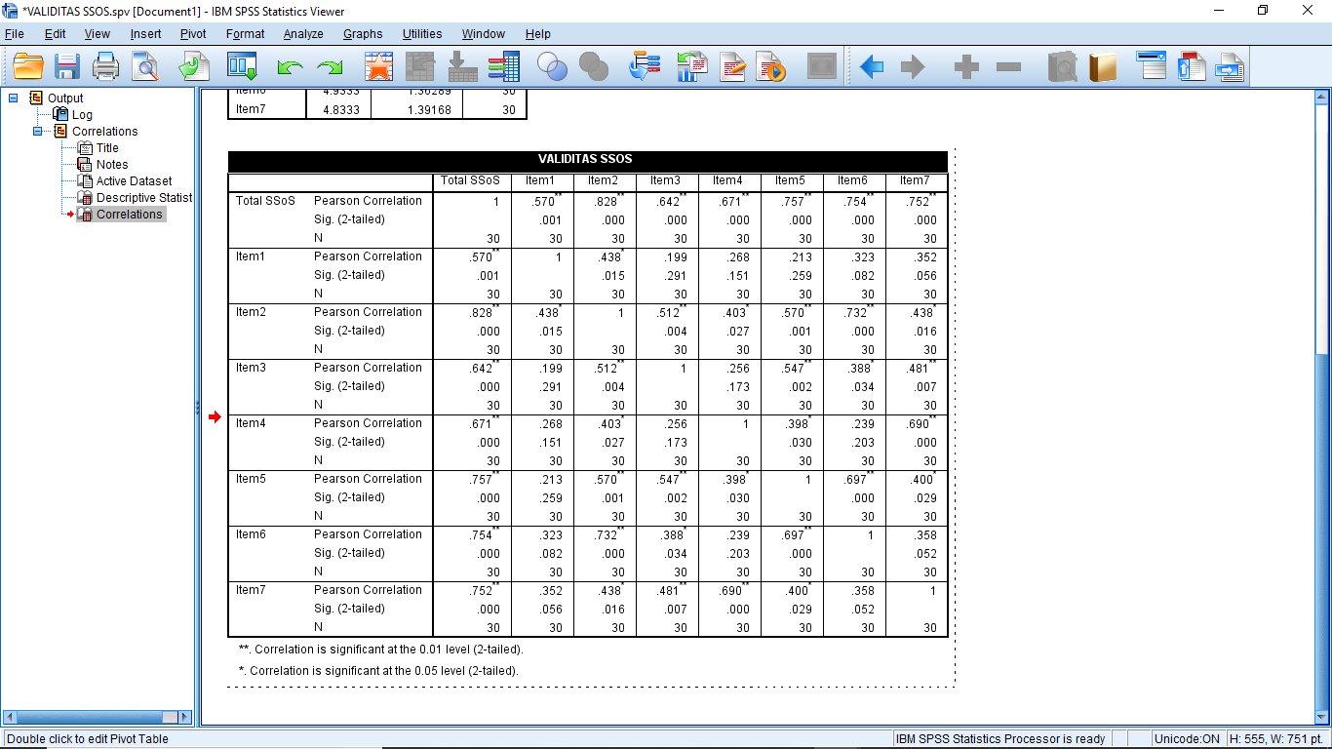

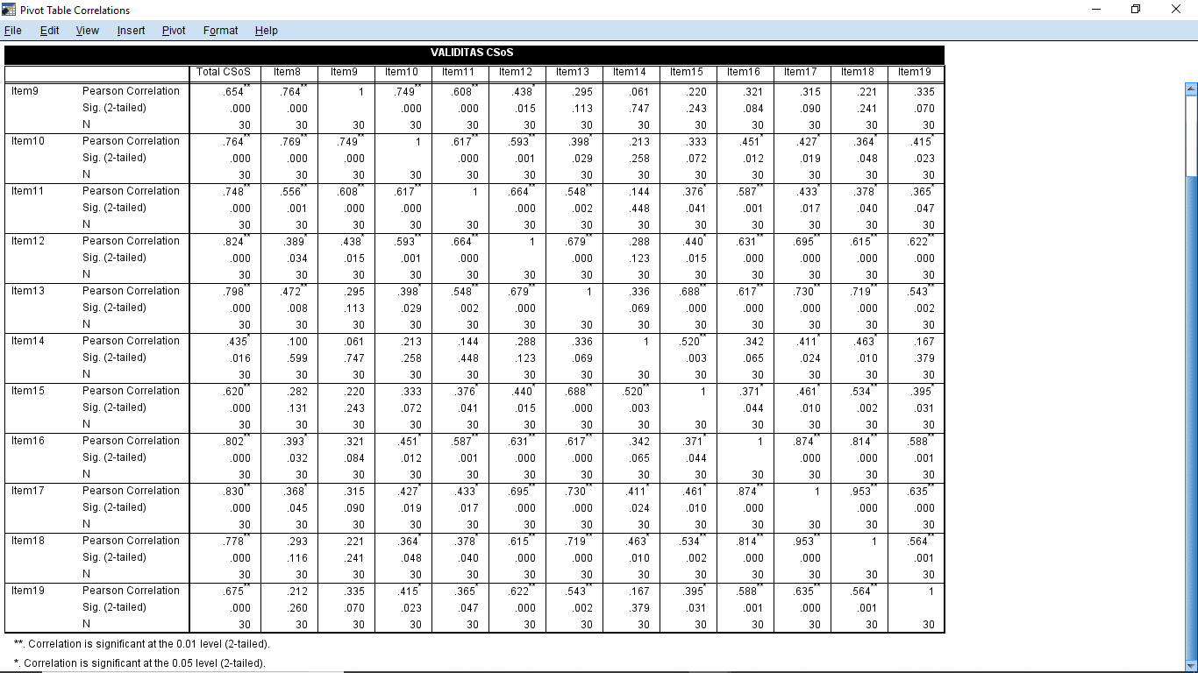
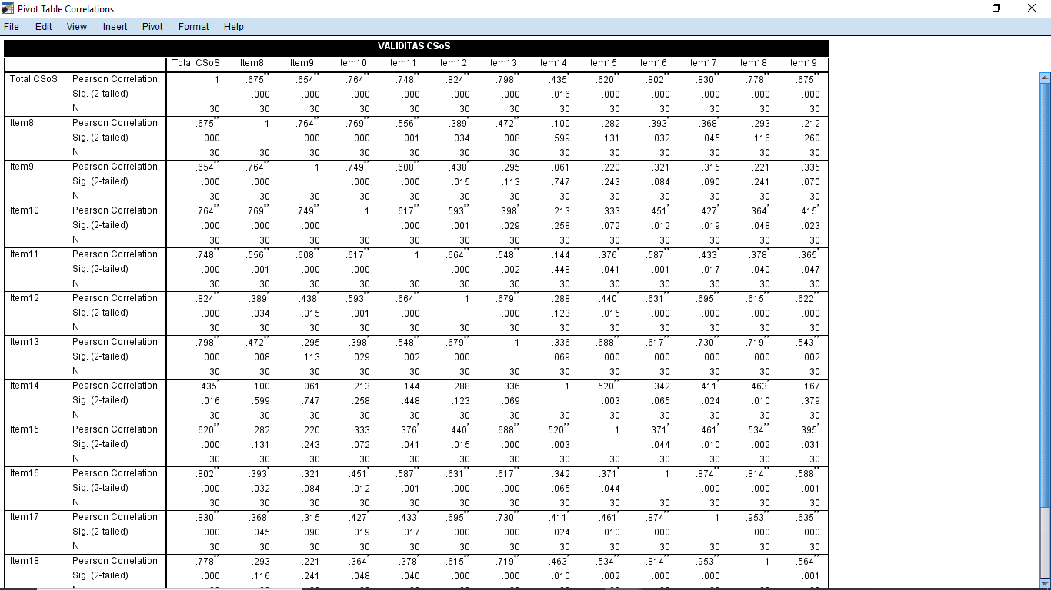
- Validitas Communicative Staging of Servicescape (CS)

3. Validitas Emotion (EMO)
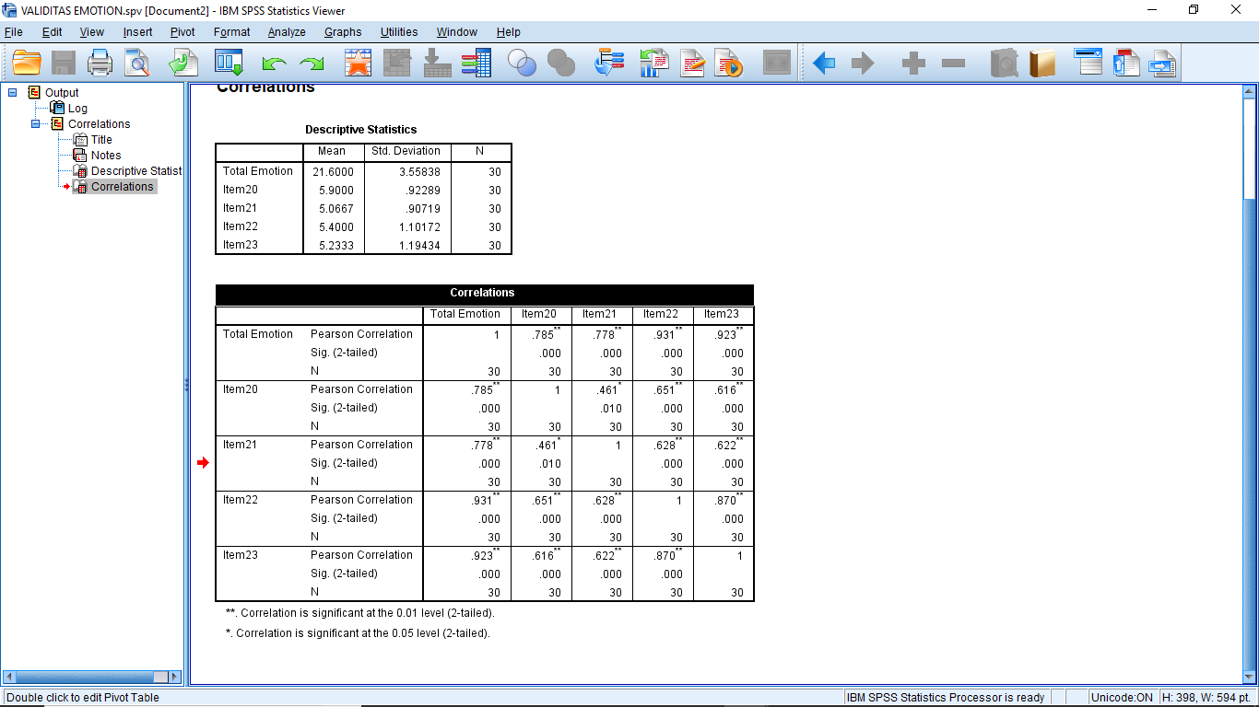

4. Validitas Satisfaction (SAT)
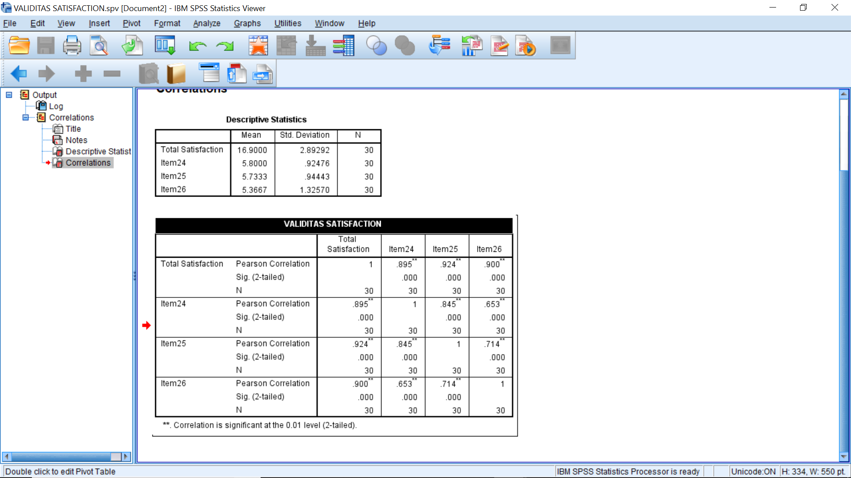

5. Validitas Subjective Well-Being (SWB)
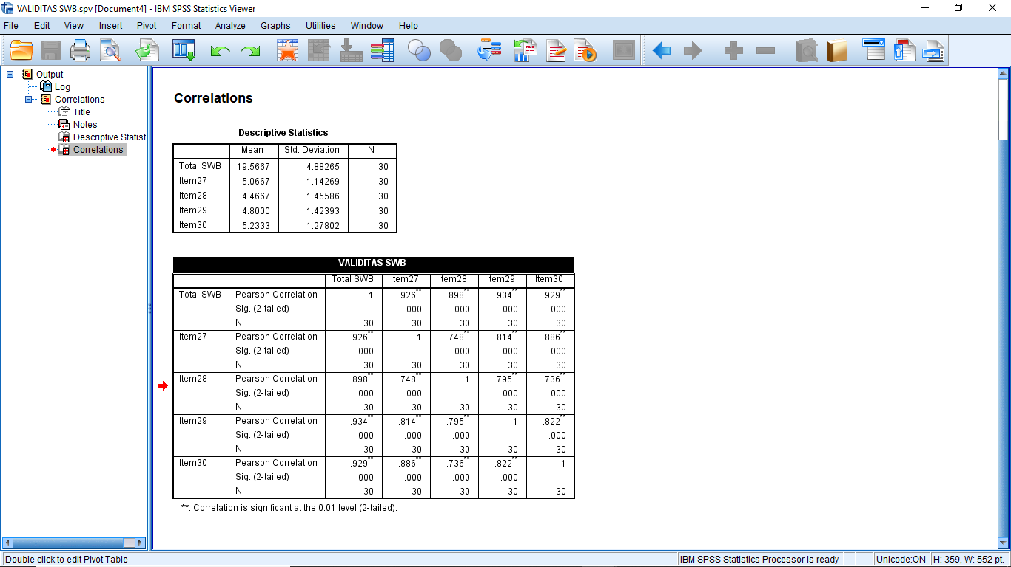

6. Validitas Overall Qualityof Life (OQL)
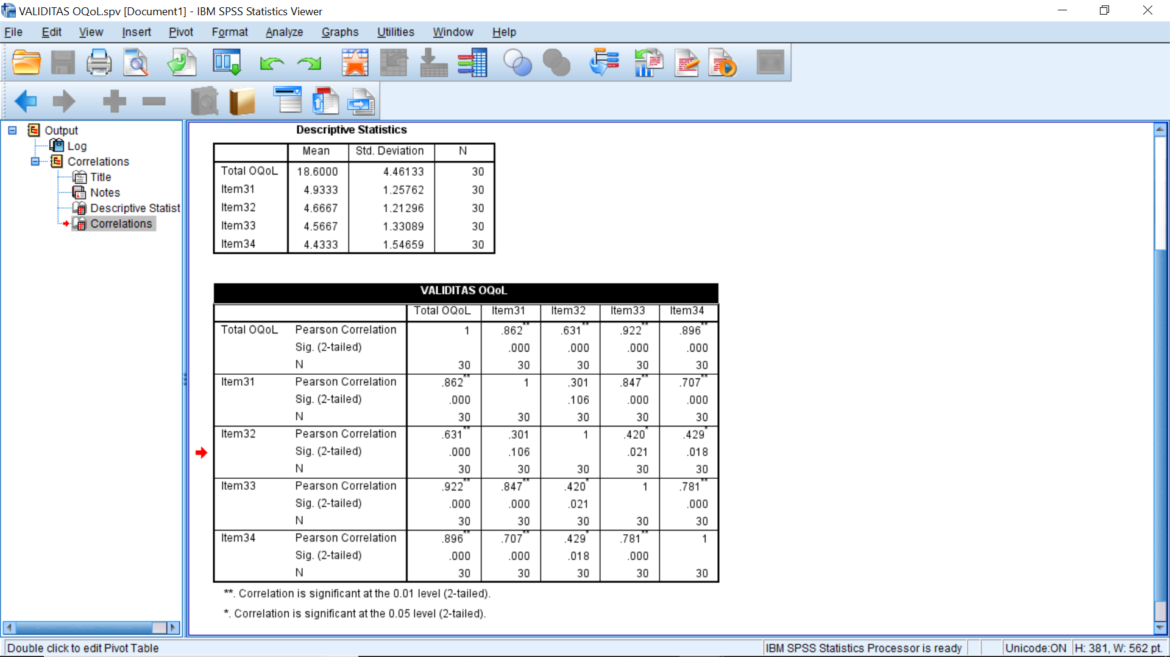

7. Validitas Loyalty (LYT)
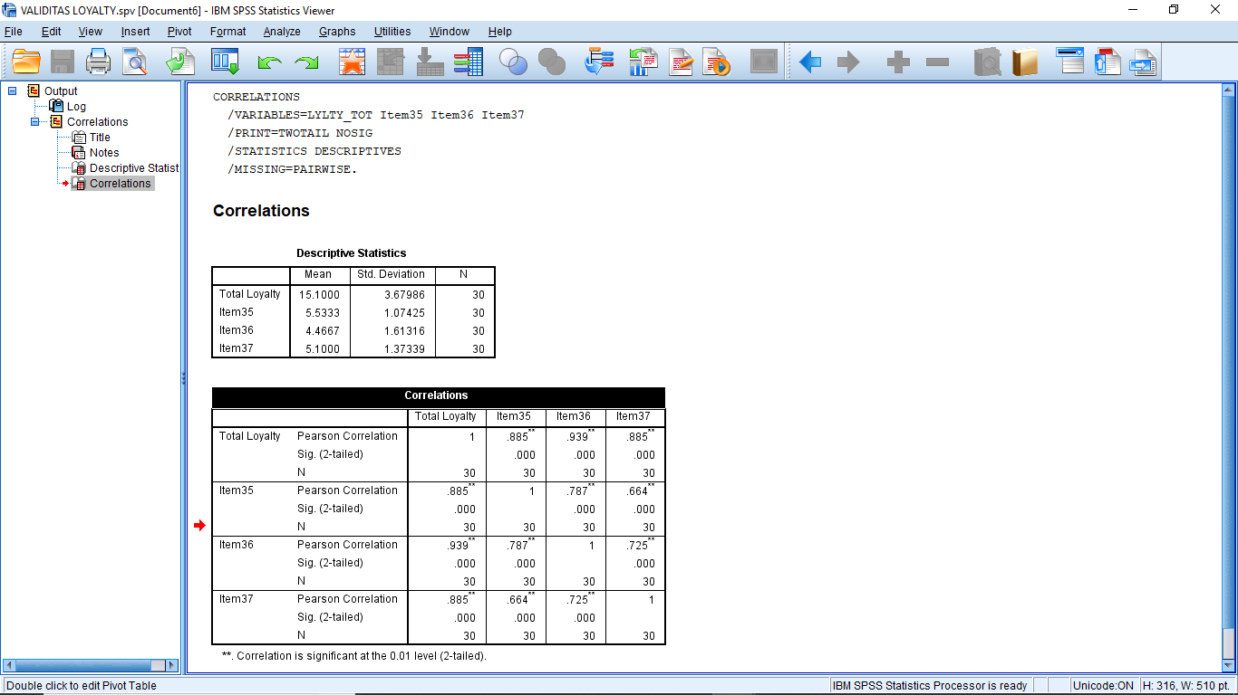

8. Validitas Return Intention (RI)
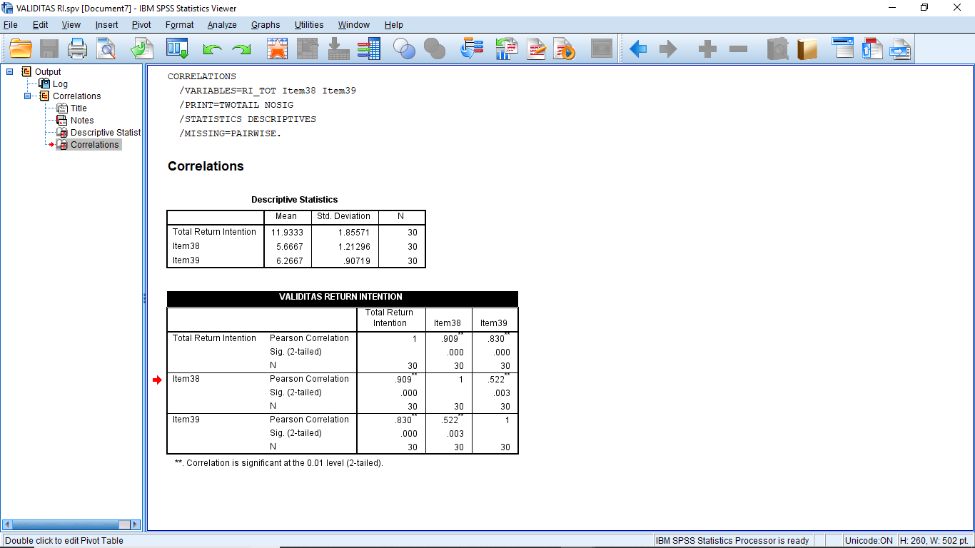

9. Validitas Word of Mouth Intention (WOM)
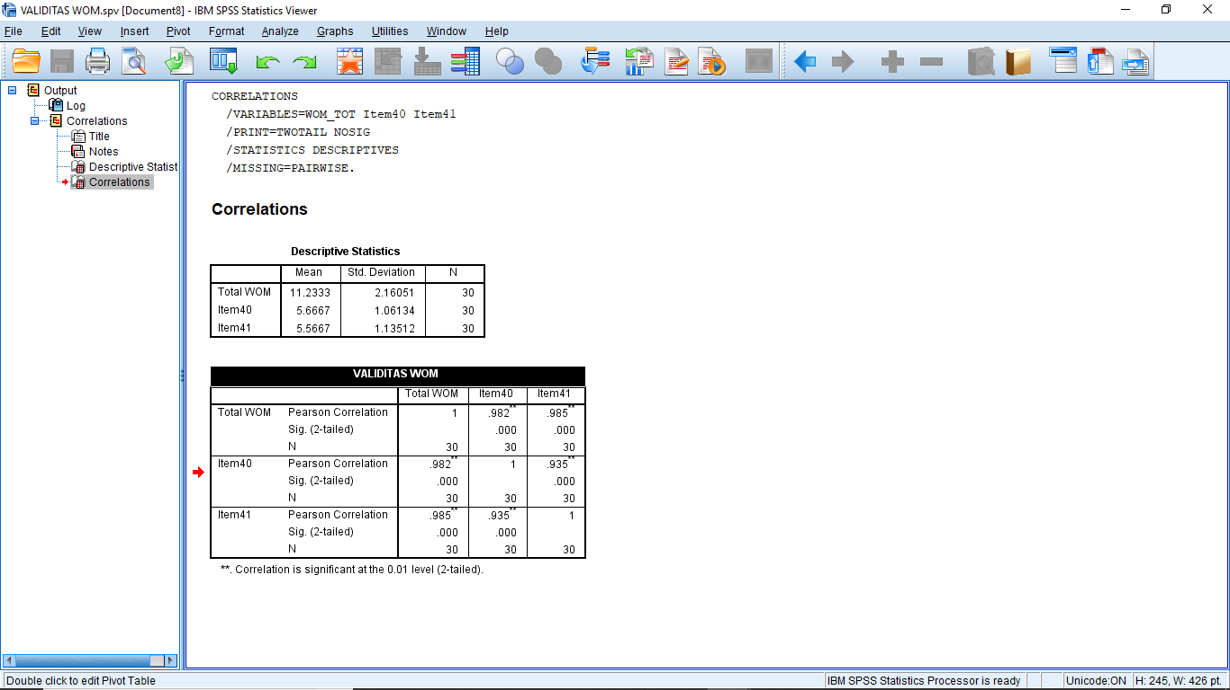

10. Validitas Electronic Word of Mouth (EWOM)

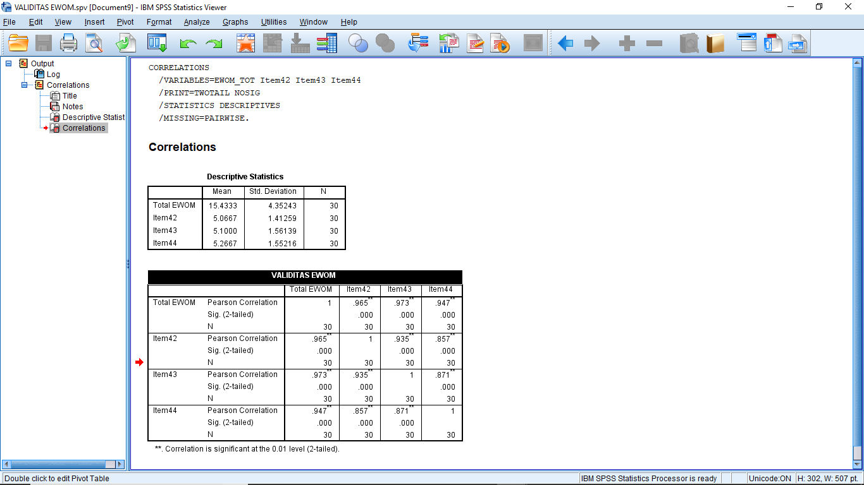

LAMPIRAN 3
HASIL UJI RELIABILITAS (30 DATA RESPONDEN)

1. Reliabilitas Substantive Staging of Servicescape (SS)
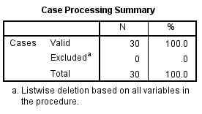

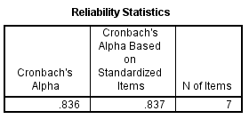

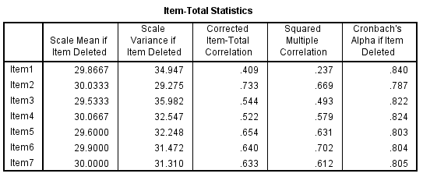

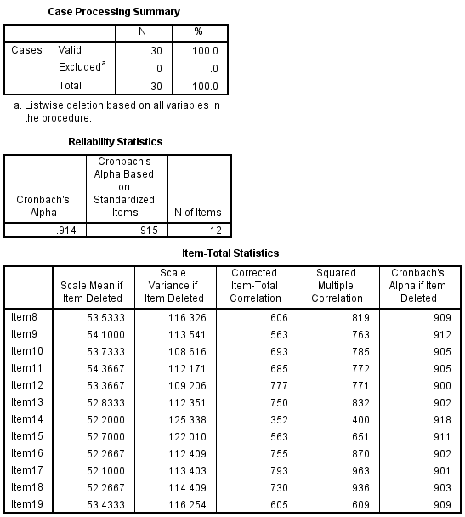
2. Reliabilitas Communication Staging of Servicescape (CS)

3. Reliabilitas Emoti

4. Reliabilitas Satisfaction (SAT)
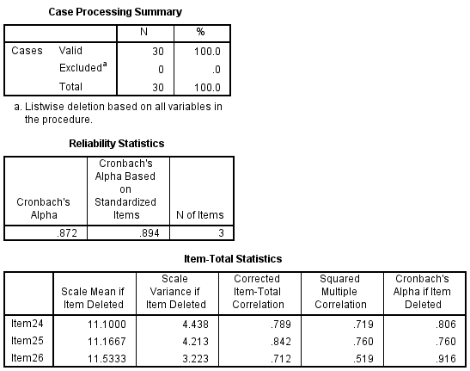

5. Reliabilitas Subjective Well-Being (SWB)
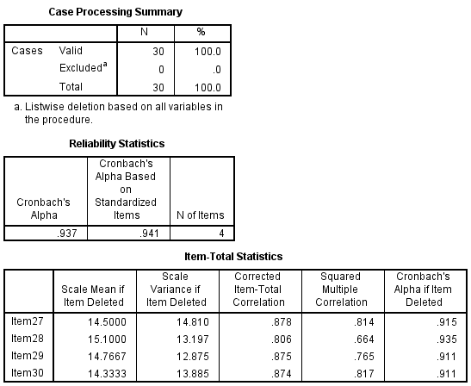

6. Reliabilitas Quality of Life (QOL)
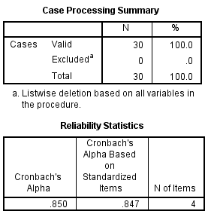

Item-Total Statistics
 | Scale Mean if Item Deleted | Scale Variance if Item Deleted | Corrected Item-Total Correlation | Squared Multiple Correlation | Cronbach's Alpha if Item Deleted
Item31 | 13.6667 | 11.816 | .752 | .729 | .785
Item32 | 13.9333 | 14.547 | .420 | .218 | .908
Item33 | 14.0333 | 10.723 | .850 | .794 | .738
Item34 | 14.1667 | 9.937 | .777 | .632 | .772

7. Reliabilitas Loyalty (LYT)
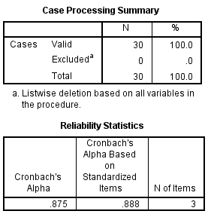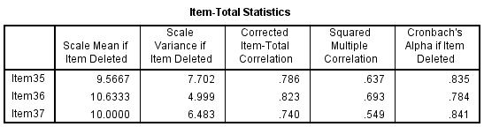

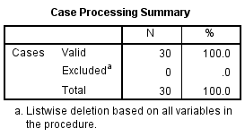
8. Reliabilitas Return Intention (RI)

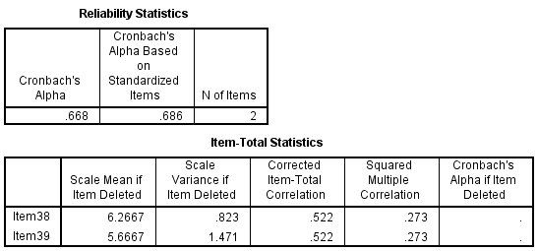

9. Reliabilitas Word of Mouth Intention (WOM)
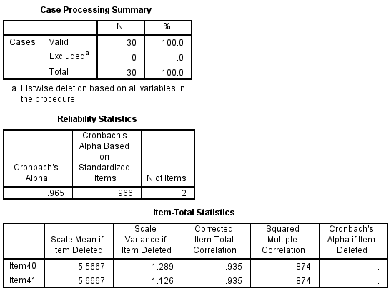

10. Reliabilitas Electronic Word of Mouth (EWOM)
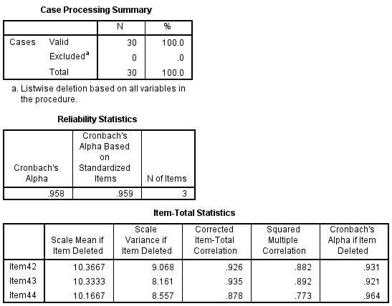

LAMPIRAN 4
HASIL STATISTIK DESKRIPTIF DATA PENELITIAN
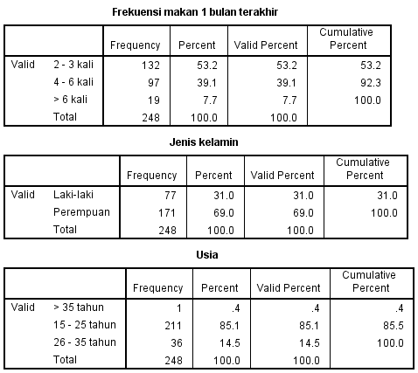
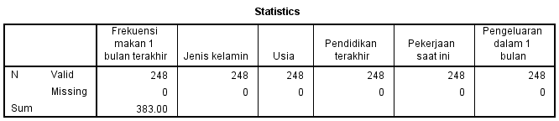

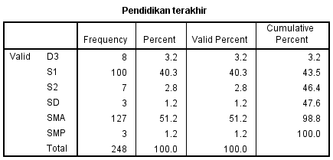

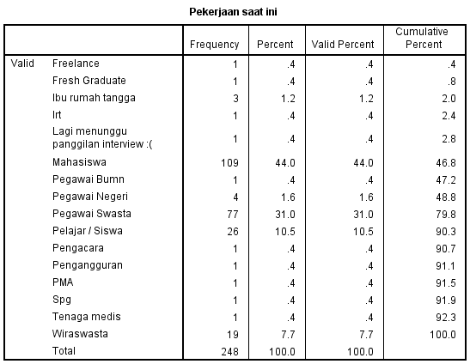

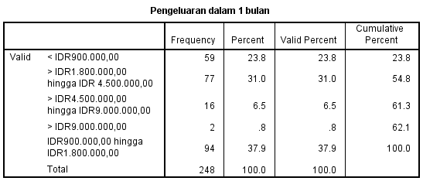

LAMPIRAN 5
STATISTIKA DESKRIPTIF TANGGAPAN RESPONDEN
(248 responden)

1. Substantive Staging of Servicescape (SS)
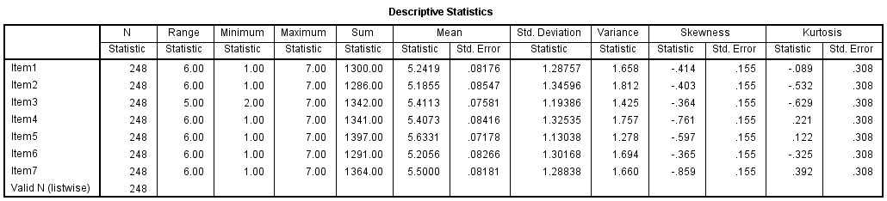

2. Communicative Staging of Servicescape (CS)
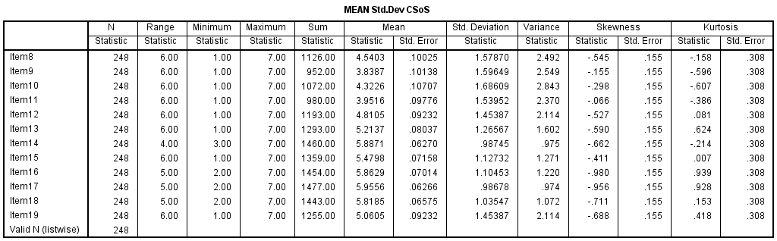

3. EMOTION (EMO)

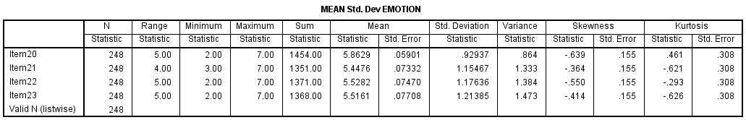
4. Satisfaction (SAT)

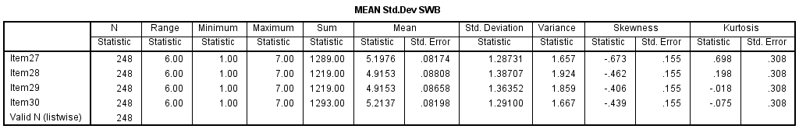
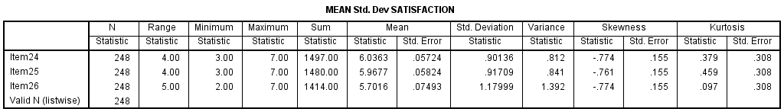
5. Subjective Well-Being (SWB)

6. Overall Quality of Life (OQL)
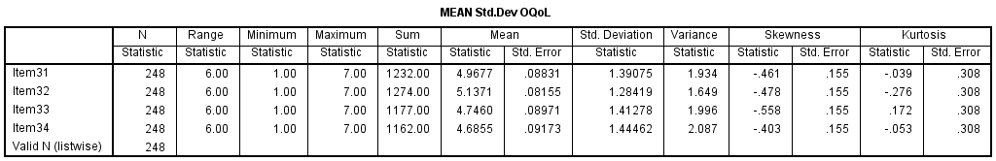

7. Loyalty (LYT)
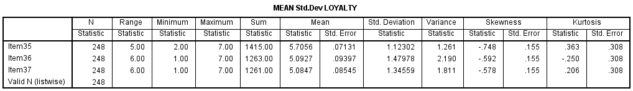

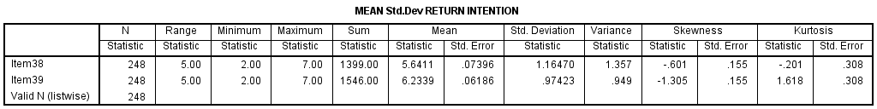
8. Return Intention (RI)

9. Word of Mouth Intention (WOM)
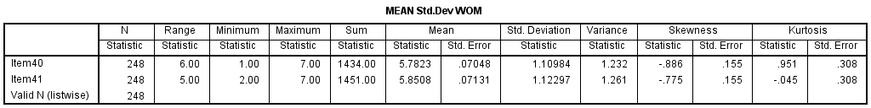

10. Electronic Word of Mouth (EWOM)
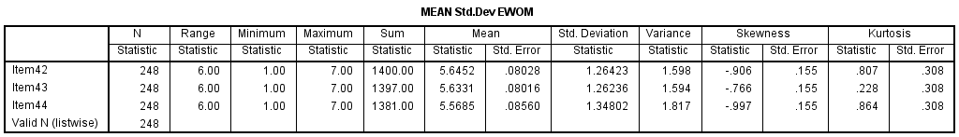

LAMPIRAN 6
MODEL PENGUKURAN PENELITIAN

1. MODEL PENGUKURAN TAHAP 1
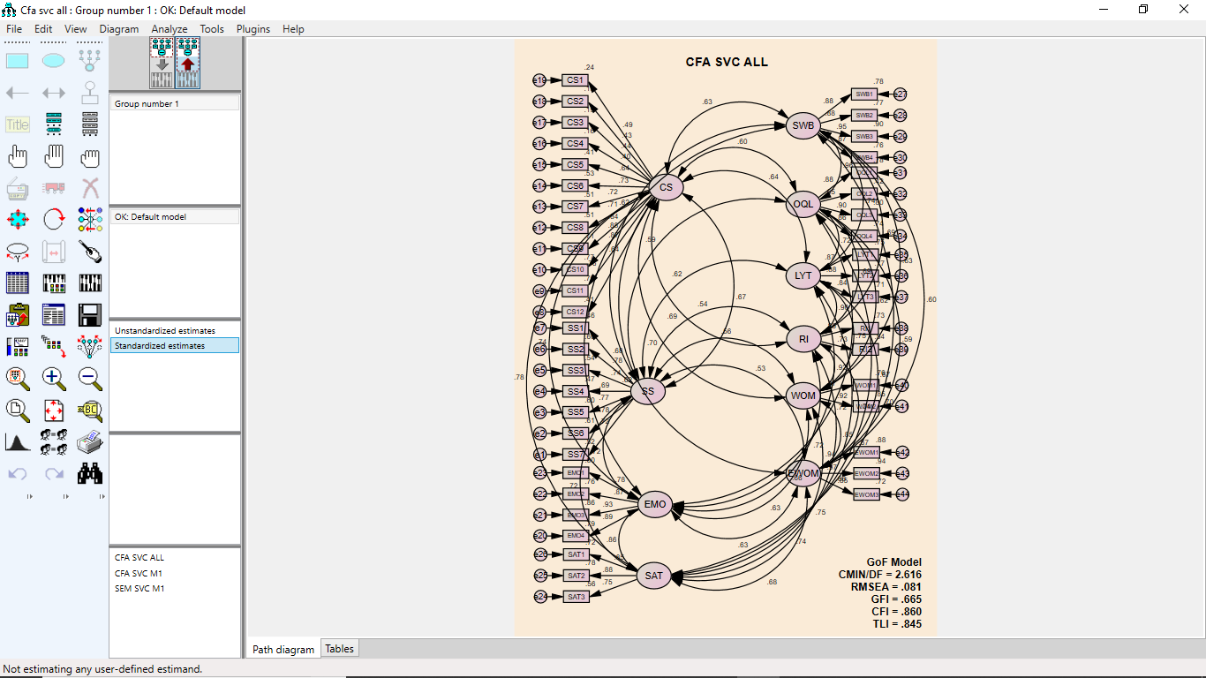

Regression Weights: (Group number 1 - Default model)

 |  |  | Estimate | S.E. | C.R. | P | Label
SS5 | <--- | SS | .945 | .082 | 11.582 | *** | par_1
SS4 | <--- | SS | .983 | .092 | 10.630 | *** | par_2
SS3 | <--- | SS | .951 | .087 | 10.888 | *** | par_3
CS8 | <--- | CS | .869 | .089 | 9.783 | *** | par_4
CS7 | <--- | CS | .763 | .078 | 9.797 | *** | par_5
CS6 | <--- | CS | .993 | .101 | 9.865 | *** | par_6
CS5 | <--- | CS | 1.010 | .113 | 8.924 | *** | par_7
EMO4 | <--- | EMO | 1.000
EMO3 | <--- | EMO | 1.011 | .044 | 22.883 | *** | par_8
EMO2 | <--- | EMO | .934 | .047 | 19.726 | *** | par_9
EMO1 | <--- | EMO | .669 | .043 | 15.691 | *** | par_10
SAT3 | <--- | SAT | 1.000
SAT2 | <--- | SAT | .913 | .065 | 13.989 | *** | par_11
SAT1 | <--- | SAT | .862 | .065 | 13.252 | *** | par_12
SWB1 | <--- | SWB | 1.000
SWB2 | <--- | SWB | 1.071 | .053 | 20.134 | *** | par_13
SWB3 | <--- | SWB | 1.134 | .047 | 24.014 | *** | par_14
SWB4 | <--- | SWB | .987 | .050 | 19.624 | *** | par_15
OQL1 | <--- | OQL | 1.000
OQL2 | <--- | OQL | .677 | .058 | 11.765 | *** | par_16
OQL3 | <--- | OQL | 1.032 | .051 | 20.255 | *** | par_17
OQL4 | <--- | OQL | 1.010 | .055 | 18.496 | *** | par_18
LYT1 | <--- | LYT | 1.000
LYT2 | <--- | LYT | 1.335 | .073 | 18.409 | *** | par_19
LYT3 | <--- | LYT | 1.167 | .071 | 16.475 | *** | par_20
RI1 | <--- | RI | 1.000
RI2 | <--- | RI | .719 | .054 | 13.236 | *** | par_21
WOM1 | <--- | WOM | 1.000
WOM2 | <--- | WOM | 1.070 | .053 | 20.175 | *** | par_22
EWOM1 | <--- | EWOM | 1.000
EWOM2 | <--- | EWOM | 1.030 | .032 | 32.670 | *** | par_23
EWOM3 | <--- | EWOM | .962 | .046 | 20.875 | *** | par_24
CS4 | <--- | CS | .665 | .114 | 5.816 | *** | par_25
SS2 | <--- | SS | 1.131 | .102 | 11.123 | *** | par_26
SS6 | <--- | SS | 1.099 | .096 | 11.484 | *** | par_27
CS9 | <--- | CS | 1.003 | .092 | 10.855 | *** | par_28
CS1 | <--- | CS | .828 | .119 | 6.955 | *** | par_74
CS2 | <--- | CS | .744 | .119 | 6.235 | *** | par_75
CS3 | <--- | CS | .801 | .126 | 6.366 | *** | par_76
CS10 | <--- | CS | .937 | .084 | 11.153 | *** | par_77
CS11 | <--- | CS | .967 | .087 | 11.072 | *** | par_78
CS12 | <--- | CS | 1.000
SS1 | <--- | SS | .947 | .095 | 9.960 | *** | par_79
SS7 | <--- | SS | 1.000

Standardized Regression Weights: (Group number 1 - Default model)

 |  |  | Estimate
SS5 | <--- | SS | .774
SS4 | <--- | SS | .686
SS3 | <--- | SS | .738
CS8 | <--- | CS | .714
CS7 | <--- | CS | .716
CS6 | <--- | CS | .727
CS5 | <--- | CS | .644
EMO4 | <--- | EMO | .889
EMO3 | <--- | EMO | .928
EMO2 | <--- | EMO | .873
EMO1 | <--- | EMO | .778
SAT3 | <--- | SAT | .750
SAT2 | <--- | SAT | .881
SAT1 | <--- | SAT | .847
SWB1 | <--- | SWB | .884
SWB2 | <--- | SWB | .878
SWB3 | <--- | SWB | .946
SWB4 | <--- | SWB | .869
OQL1 | <--- | OQL | .883
OQL2 | <--- | OQL | .647
OQL3 | <--- | OQL | .897
OQL4 | <--- | OQL | .858
LYT1 | <--- | LYT | .866
LYT2 | <--- | LYT | .878
LYT3 | <--- | LYT | .843
RI1 | <--- | RI | .852
RI2 | <--- | RI | .732
WOM1 | <--- | WOM | .869
WOM2 | <--- | WOM | .919
EWOM1 | <--- | EWOM | .939
EWOM2 | <--- | EWOM | .968
EWOM3 | <--- | EWOM | .847
CS4 | <--- | CS | .400
SS2 | <--- | SS | .778
SS6 | <--- | SS | .782
CS9 | <--- | CS | .841
CS1 | <--- | CS | .486
CS2 | <--- | CS | .432
CS3 | <--- | CS | .440
CS10 | <--- | CS | .879
CS11 | <--- | CS | .865
CS12 | <--- | CS | .637
SS1 | <--- | SS | .681
SS7 | <--- | SS | .719

MODEL FIT SUMARRY

CMIN
Model | NPAR | CMIN | DF | P | CMIN/DF
Default model | 133 | 2241.532 | 857 | .000 | 2.616
Saturated model | 990 | .000 | 0
Independence model | 44 | 10812.070 | 946 | .000 | 11.429

RMR, GFI
Model | RMR | GFI | AGFI | PGFI
Default model | .144 | .665 | .612 | .575
Saturated model | .000 | 1.000
Independence model | .724 | .094 | .052 | .090

Baseline Comparisons
Model | NFI  Delta1 | RFI  rho1 | IFI  Delta2 | TLI  rho2 | CFI
Default model | .793 | .771 | .861 | .845 | .860
Saturated model | 1.000 |  | 1.000 |  | 1.000
Independence model | .000 | .000 | .000 | .000 | .000

Parsimony-Adjusted Measures
Model | PRATIO | PNFI | PCFI
Default model | .906 | .718 | .779
Saturated model | .000 | .000 | .000
Independence model | 1.000 | .000 | .000

NCP
Model | NCP | LO 90 | HI 90
Default model | 1384.532 | 1248.231 | 1528.459
Saturated model | .000 | .000 | .000
Independence model | 9866.070 | 9534.813 | 10203.799

FMIN
Model | FMIN | F0 | LO 90 | HI 90
Default model | 9.075 | 5.605 | 5.054 | 6.188
Saturated model | .000 | .000 | .000 | .000
Independence model | 43.774 | 39.944 | 38.602 | 41.311

RMSEA
Model | RMSEA | LO 90 | HI 90 | PCLOSE
Default model | .081 | .077 | .085 | .000
Independence model | .205 | .202 | .209 | .000

AIC
Model | AIC | BCC | BIC | CAIC
Default model | 2507.532 | 2566.789 | 2974.818 | 3107.818
Saturated model | 1980.000 | 2421.089 | 5458.294 | 6448.294
Independence model | 10900.070 | 10919.674 | 11054.661 | 11098.661

ECVI
Model | ECVI | LO 90 | HI 90 | MECVI
Default model | 10.152 | 9.600 | 10.735 | 10.392
Saturated model | 8.016 | 8.016 | 8.016 | 9.802
Independence model | 44.130 | 42.789 | 45.497 | 44.209

HOELTER
Model | HOELTER  .05 | HOELTER  .01
Default model | 103 | 106
Independence model | 24 | 24
2. MODEL PENGUKURAN TAHAP 2
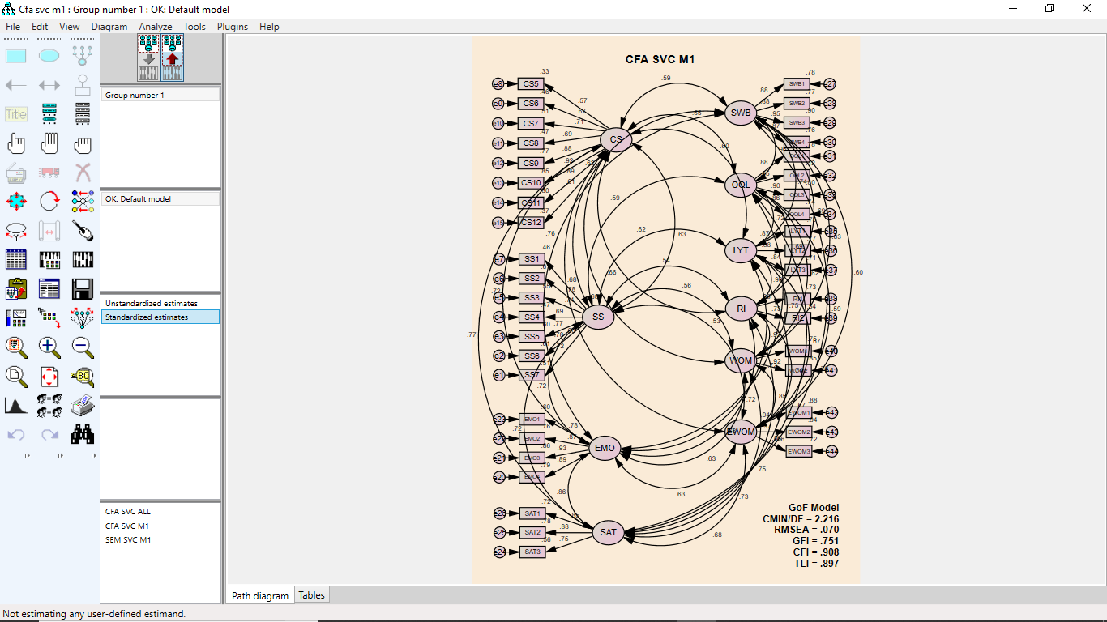

Regression Weights: (Group number 1 - Default model)

 |  |  | Estimate | S.E. | C.R. | P | Label
SS5 | <--- | SS | .946 | .082 | 11.566 | *** | par_1
SS4 | <--- | SS | .983 | .093 | 10.598 | *** | par_2
SS3 | <--- | SS | .954 | .088 | 10.880 | *** | par_3
EMO4 | <--- | EMO | 1.000
EMO3 | <--- | EMO | 1.011 | .044 | 22.888 | *** | par_4
EMO2 | <--- | EMO | .934 | .047 | 19.729 | *** | par_5
EMO1 | <--- | EMO | .669 | .043 | 15.690 | *** | par_6
SAT3 | <--- | SAT | 1.000
SAT2 | <--- | SAT | .917 | .066 | 13.958 | *** | par_7
SAT1 | <--- | SAT | .868 | .066 | 13.243 | *** | par_8
SWB1 | <--- | SWB | 1.000
SWB2 | <--- | SWB | 1.071 | .053 | 20.135 | *** | par_9
SWB3 | <--- | SWB | 1.134 | .047 | 24.016 | *** | par_10
SWB4 | <--- | SWB | .986 | .050 | 19.617 | *** | par_11
OQL1 | <--- | OQL | 1.000
OQL2 | <--- | OQL | .676 | .058 | 11.763 | *** | par_12
OQL3 | <--- | OQL | 1.032 | .051 | 20.258 | *** | par_13
OQL4 | <--- | OQL | 1.010 | .055 | 18.502 | *** | par_14
LYT1 | <--- | LYT | 1.000
LYT2 | <--- | LYT | 1.335 | .073 | 18.409 | *** | par_15
LYT3 | <--- | LYT | 1.167 | .071 | 16.480 | *** | par_16
RI1 | <--- | RI | 1.000
RI2 | <--- | RI | .719 | .054 | 13.222 | *** | par_17
WOM1 | <--- | WOM | 1.000
WOM2 | <--- | WOM | 1.072 | .053 | 20.188 | *** | par_18
EWOM1 | <--- | EWOM | 1.000
EWOM2 | <--- | EWOM | 1.030 | .032 | 32.669 | *** | par_19
EWOM3 | <--- | EWOM | .962 | .046 | 20.874 | *** | par_20
SS2 | <--- | SS | 1.134 | .102 | 11.106 | *** | par_21
SS6 | <--- | SS | 1.102 | .096 | 11.474 | *** | par_22
SS1 | <--- | SS | .947 | .095 | 9.927 | *** | par_68
SS7 | <--- | SS | 1.000
CS12 | <--- | CS | 1.000
CS11 | <--- | CS | 1.045 | .096 | 10.835 | *** | par_69
CS10 | <--- | CS | 1.023 | .093 | 10.986 | *** | par_70
CS9 | <--- | CS | 1.092 | .102 | 10.711 | *** | par_71
CS8 | <--- | CS | .872 | .095 | 9.141 | *** | par_72
CS7 | <--- | CS | .796 | .084 | 9.418 | *** | par_73
CS6 | <--- | CS | .963 | .107 | 9.000 | *** | par_74
CS5 | <--- | CS | .936 | .118 | 7.903 | *** | par_75

Standardized Regression Weights: (Group number 1 - Default model)

 |  |  | Estimate
SS5 | <--- | SS | .774
SS4 | <--- | SS | .685
SS3 | <--- | SS | .738
EMO4 | <--- | EMO | .889
EMO3 | <--- | EMO | .928
EMO2 | <--- | EMO | .873
EMO1 | <--- | EMO | .777
SAT3 | <--- | SAT | .747
SAT2 | <--- | SAT | .881
SAT1 | <--- | SAT | .849
SWB1 | <--- | SWB | .883
SWB2 | <--- | SWB | .878
SWB3 | <--- | SWB | .946
SWB4 | <--- | SWB | .869
OQL1 | <--- | OQL | .883
OQL2 | <--- | OQL | .647
OQL3 | <--- | OQL | .897
OQL4 | <--- | OQL | .858
LYT1 | <--- | LYT | .866
LYT2 | <--- | LYT | .878
LYT3 | <--- | LYT | .843
RI1 | <--- | RI | .852
RI2 | <--- | RI | .732
WOM1 | <--- | WOM | .868
WOM2 | <--- | WOM | .920
EWOM1 | <--- | EWOM | .939
EWOM2 | <--- | EWOM | .968
EWOM3 | <--- | EWOM | .847
SS2 | <--- | SS | .778
SS6 | <--- | SS | .783
SS1 | <--- | SS | .680
SS7 | <--- | SS | .717
CS12 | <--- | CS | .610
CS11 | <--- | CS | .895
CS10 | <--- | CS | .920
CS9 | <--- | CS | .876
CS8 | <--- | CS | .686
CS7 | <--- | CS | .714
CS6 | <--- | CS | .675
CS5 | <--- | CS | .571

MODEL FIT SUMARRY

CMIN
Model | NPAR | CMIN | DF | P | CMIN/DF
Default model | 125 | 1539.855 | 695 | .000 | 2.216
Saturated model | 820 | .000 | 0
Independence model | 40 | 9951.610 | 780 | .000 | 12.758

RMR, GFI
Model | RMR | GFI | AGFI | PGFI
Default model | .103 | .751 | .706 | .636
Saturated model | .000 | 1.000
Independence model | .731 | .094 | .047 | .089

Baseline Comparisons
Model | NFI  Delta1 | RFI  rho1 | IFI  Delta2 | TLI  rho2 | CFI
Default model | .845 | .826 | .909 | .897 | .908
Saturated model | 1.000 |  | 1.000 |  | 1.000
Independence model | .000 | .000 | .000 | .000 | .000

Parsimony-Adjusted Measures
Model | PRATIO | PNFI | PCFI
Default model | .891 | .753 | .809
Saturated model | .000 | .000 | .000
Independence model | 1.000 | .000 | .000

NCP
Model | NCP | LO 90 | HI 90
Default model | 844.855 | 735.083 | 962.339
Saturated model | .000 | .000 | .000
Independence model | 9171.610 | 8853.166 | 9496.507

FMIN
Model | FMIN | F0 | LO 90 | HI 90
Default model | 6.234 | 3.420 | 2.976 | 3.896
Saturated model | .000 | .000 | .000 | .000
Independence model | 40.290 | 37.132 | 35.843 | 38.447

RMSEA
Model | RMSEA | LO 90 | HI 90 | PCLOSE
Default model | .070 | .065 | .075 | .000
Independence model | .218 | .214 | .222 | .000

AIC
Model | AIC | BCC | BIC | CAIC
Default model | 1789.855 | 1839.613 | 2229.034 | 2354.034
Saturated model | 1640.000 | 1966.408 | 4521.012 | 5341.012
Independence model | 10031.610 | 10047.533 | 10172.147 | 10212.147

ECVI
Model | ECVI | LO 90 | HI 90 | MECVI
Default model | 7.246 | 6.802 | 7.722 | 7.448
Saturated model | 6.640 | 6.640 | 6.640 | 7.961
Independence model | 40.614 | 39.325 | 41.929 | 40.678

HOELTER
Model | HOELTER  .05 | HOELTER  .01
Default model | 122 | 126
Independence model | 21 | 22

LAMPIRAN 7
HASIL UJI UNIDIMENSIONAL

Substantive Staging of Servicescape (SS)
Item | Standardized loading 1 | Standardized loading 2 | Measurement error
SS1 | 0.681 | 0.463761 | 0.536239
SS2 | 0.778 | 0.605284 | 0.394716
SS3 | 0.738 | 0.544644 | 0.455356
SS4 | 0.686 | 0.470596 | 0.529404
SS5 | 0.774 | 0.599076 | 0.400924
SS6 | 0.782 | 0.611524 | 0.388476
SS7 | 0.719 | 0.516961 | 0.483039
TOTAL | 5.158 | 3.811846 | 3.188154
CR | 0.892990254
AVE | 0.544549429
Communicative Staging of Servicescape (CS)
Item | Standardized loading 1 | Standardized loading 2 | Measurement error
CS5 | 0.644 | 0.414736 | 0.585264
CS6 | 0.727 | 0.528529 | 0.471471
CS7 | 0.716 | 0.512656 | 0.487344
CS8 | 0.714 | 0.509796 | 0.490204
CS9 | 0.841 | 0.707281 | 0.292719
CS10 | 0.879 | 0.772641 | 0.227359
CS11 | 0.865 | 0.748225 | 0.251775
CS12 | 0.637 | 0.405769 | 0.594231
TOTAL | 6.023 | 4.599633 | 3.400367
CR | 0.914298563
AVE | 0.574954125
EMOTION (EMO)
Item | Standardized loading 1 | Standardized loading 2 | Measurement error
EMO1 | 0.778 | 0.605284 | 0.394716
EMO2 | 0.873 | 0.762129 | 0.237871
EMO3 | 0.928 | 0.861184 | 0.138816
EMO4 | 0.889 | 0.790321 | 0.209679
TOTAL | 3.468 | 3.018918 | 0.981082
CR | 0.924579182
AVE | 0.7547295

SATISFACTION (SAT)
Item | Standardized loading 1 | Standardized loading 2 | Measurement error
SAT1 | 0.847 | 0.717409 | 0.282591
SAT2 | 0.881 | 0.776161 | 0.223839
SAT3 | 0.75 | 0.5625 | 0.4375
TOTAL | 2.478 | 2.05607 | 0.94393
CR | 0.866759622
AVE | 0.685356667
Overall Quality of Life (OQL)
Item | Standardized loading 1 | Standardized loading 2 | Measurement error
OQL1 | 0.883 | 0.779689 | 0.220311
OQL2 | 0.647 | 0.418609 | 0.581391
OQL3 | 0.897 | 0.804609 | 0.195391
OQL4 | 0.858 | 0.736164 | 0.263836
TOTAL | 3.285 | 2.739071 | 1.260929
CR | 0.895377291
AVE | 0.68476775
LOYALTY (LYT)
Item | Standardized loading 1 | Standardized loading 2 | Measurement error
LYT1 | 0.866 | 0.749956 | 0.250044
LYT2 | 0.878 | 0.770884 | 0.229116
LYT3 | 0.843 | 0.710649 | 0.289351
TOTAL | 2.587 | 2.231489 | 0.768511
CR | 0.896997352
AVE | 0.743829667
Return Intention (RI)
Item | Standardized loading 1 | Standardized loading 2 | Measurement error
RI1 | 0.852 | 0.725904 | 0.274096
RI2 | 0.732 | 0.535824 | 0.464176
TOTAL | 1.584 | 1.261728 | 0.738272
CR | 0.77265247
AVE | 0.630864

Subjective Well Being(SWB)
Item | Standardized loading 1 | Standardized loading 2 | Measurement error
SWB1 | 0.884 | 0.781456 | 0.218544
SWB2 | 0.878 | 0.770884 | 0.229116
SWB3 | 0.946 | 0.894916 | 0.105084
TOTAL | 2.708 | 2.447256 | 0.552744
CR | 0.929908263
AVE | 0.815752
Word of Mouth (WOM)
Item | Standardized loading 1 | Standardized loading 2 | Measurement error
WOM1 | 0.869 | 0.755161 | 0.244839
WOM2 | 0.919 | 0.844561 | 0.155439
TOTAL | 1.788 | 1.599722 | 0.400278
CR | 0.8887258
AVE | 0.799861
Electronic Word of Mouth (EWOM)
Item | Standardized loading 1 | Standardized loading 2 | Measurement error
EWOM1 | 0.939 | 0.881721 | 0.118279
EWOM2 | 0.968 | 0.937024 | 0.062976
EWOM3 | 0.847 | 0.717409 | 0.282591
TOTAL | 2.754 | 2.536154 | 0.463846
CR | 0.942367652
AVE | 0.845384667

Average Variance Extracted

Variabel | (∑std.loading)² | ∑error | AVE | KET.
Substantive Staging of Servicescape  (SSoS) | 3,811846 | 3,188154 | 0,544549429 | Valid
Communicative Staging of Servicescape  (CSoS | 4,599633 | 3,400367 | 0,5749542125 | Valid
EMOTION | 3.018918 | 0.981082 | 0.7547295 | Valid
Satisfaction | 2,05607 | 0.94393 | 0,685356667 | Valid
Overall Quality of Life | 2,739071 | 1,260929 | 0,68476775 | Valid
Loyalty | 2,231489 | 0,768511 | 0,743829667 | Valid
Return Intention | 1,261728 | 0,738272 | 0,630864 | Valid
Subjective Well Being | 2,447256 | 0,552744 | 0,815752 | Valid
Word of Mouth | 1,599722 | 0,400278 | 0,799861 | Valid
Electronic Word of Mouth | 2,536154 | 0,463846 | 0,845384667 | Valid

Construct Reliability

Variabel | (∑std.loading) | (∑std.loading)² | ∑error | Construct Reliability
Substantive Staging of Servicescape  (SSoS) | 5,158 | 3,811846 | 3.188154 | 0.892990254
Communicative Staging of Servicescape  (CSoS | 6,023 | 4,599633 | 3,400367 | 0,914298563
EMOTION | 3,468 | 3,018918 | 0,981082 | 0,924579182
Satisfaction | 2,478 | 2,05607 | 0,94393 | 0,866759622
Overall Quality of Life | 3,285 | 2,739071 | 1,260929 | 0,895377291
Loyalty | 2,587 | 2,231489 | 0,768511 | 0,896997352
Return Intention | 1,584 | 1,261728 | 0,738272 | 0,77265247
Subjective Well Being | 2,708 | 2,447256 | 0,552744 | 0,929908263
Word of Mouth | 1,788 | 1,599722 | 0,400278 | 0,8887258
Electronic Word of Mouth | 2,754 | 2,536154 | 0,463846 | 0,942367652

LAMPIRAN 8
MODEL STRUKTURAN PENELITIAN

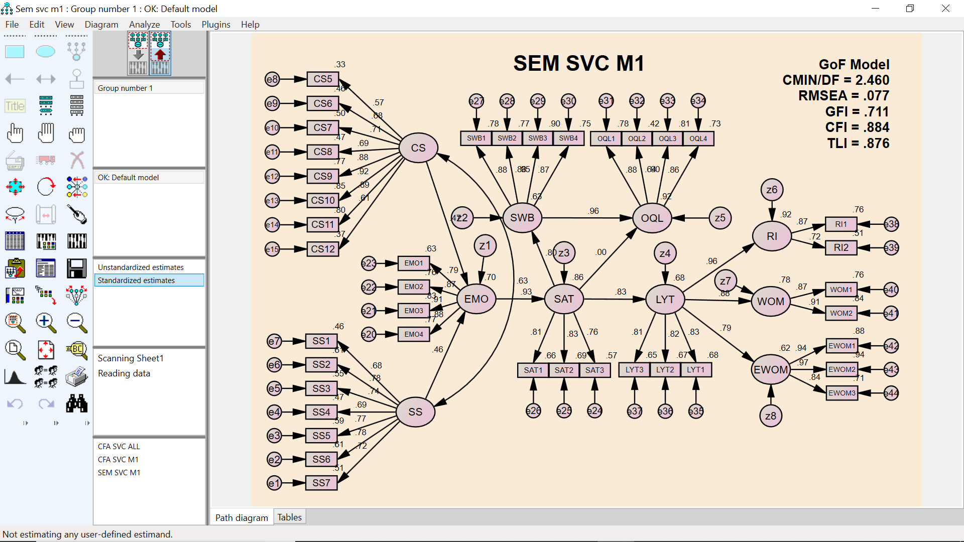

Regression Weights: (Group number 1 - Default model)

 |  |  | Estimate | S.E. | C.R. | P | Label
EMO | <--- | CS | .562 | .084 | 6.729 | *** | par_40
EMO | <--- | SS | .526 | .077 | 6.843 | *** | par_41
SAT | <--- | EMO | .779 | .057 | 13.607 | *** | par_32
LYT | <--- | SAT | .860 | .075 | 11.393 | *** | par_33
SWB | <--- | SAT | 1.016 | .087 | 11.691 | *** | par_37
RI | <--- | LYT | 1.047 | .067 | 15.620 | *** | par_34
WOM | <--- | LYT | .925 | .068 | 13.677 | *** | par_35
EWOM | <--- | LYT | 1.007 | .077 | 13.104 | *** | par_36
OQL | <--- | SAT | .000 | .081 | .005 | .996 | par_38
OQL | <--- | SWB | 1.037 | .077 | 13.529 | *** | par_39
SS5 | <--- | SS | .944 | .082 | 11.502 | *** | par_1
SS4 | <--- | SS | .986 | .093 | 10.597 | *** | par_2
SS3 | <--- | SS | .963 | .088 | 10.934 | *** | par_3
EMO4 | <--- | EMO | 1.000
EMO3 | <--- | EMO | 1.010 | .047 | 21.484 | *** | par_4
EMO2 | <--- | EMO | .947 | .049 | 19.207 | *** | par_5
EMO1 | <--- | EMO | .692 | .044 | 15.903 | *** | par_6
SAT3 | <--- | SAT | 1.000
SAT2 | <--- | SAT | .854 | .062 | 13.670 | *** | par_7
SAT1 | <--- | SAT | .823 | .062 | 13.244 | *** | par_8
SWB1 | <--- | SWB | 1.000
SWB2 | <--- | SWB | 1.070 | .053 | 20.239 | *** | par_9
SWB3 | <--- | SWB | 1.133 | .047 | 24.117 | *** | par_10
SWB4 | <--- | SWB | .982 | .050 | 19.549 | *** | par_11
OQL1 | <--- | OQL | 1.000
OQL2 | <--- | OQL | .673 | .057 | 11.724 | *** | par_12
OQL3 | <--- | OQL | 1.032 | .051 | 20.331 | *** | par_13
OQL4 | <--- | OQL | 1.006 | .055 | 18.446 | *** | par_14
LYT1 | <--- | LYT | 1.000
LYT2 | <--- | LYT | 1.303 | .084 | 15.604 | *** | par_15
LYT3 | <--- | LYT | 1.168 | .078 | 15.015 | *** | par_16
RI1 | <--- | RI | 1.000
RI2 | <--- | RI | .687 | .054 | 12.781 | *** | par_17
WOM1 | <--- | WOM | 1.000
WOM2 | <--- | WOM | 1.058 | .056 | 18.771 | *** | par_18
EWOM1 | <--- | EWOM | 1.000
EWOM2 | <--- | EWOM | 1.032 | .032 | 32.446 | *** | par_19
EWOM3 | <--- | EWOM | .960 | .046 | 20.735 | *** | par_20
SS2 | <--- | SS | 1.138 | .102 | 11.107 | *** | par_21
SS6 | <--- | SS | 1.099 | .096 | 11.416 | *** | par_22
SS1 | <--- | SS | .949 | .096 | 9.918 | *** | par_23
SS7 | <--- | SS | 1.000
CS11 | <--- | CS | 1.044 | .096 | 10.833 | *** | par_24
CS10 | <--- | CS | 1.025 | .093 | 10.994 | *** | par_25
CS9 | <--- | CS | 1.090 | .102 | 10.704 | *** | par_26
CS8 | <--- | CS | .872 | .095 | 9.143 | *** | par_27
CS7 | <--- | CS | .791 | .084 | 9.380 | *** | par_28
CS6 | <--- | CS | .965 | .107 | 9.014 | *** | par_29
CS5 | <--- | CS | .935 | .118 | 7.894 | *** | par_30
CS12 | <--- | CS | 1.000

Standardized Regression Weights: (Group number 1 - Default model)

 |  |  | Estimate
EMO | <--- | CS | .469
EMO | <--- | SS | .456
SAT | <--- | EMO | .929
LYT | <--- | SAT | .826
SWB | <--- | SAT | .796
RI | <--- | LYT | .958
WOM | <--- | LYT | .885
EWOM | <--- | LYT | .788
OQL | <--- | SAT | .000
OQL | <--- | SWB | .961
SS5 | <--- | SS | .771
SS4 | <--- | SS | .686
SS3 | <--- | SS | .744
EMO4 | <--- | EMO | .877
EMO3 | <--- | EMO | .913
EMO2 | <--- | EMO | .872
EMO1 | <--- | EMO | .793
SAT3 | <--- | SAT | .756
SAT2 | <--- | SAT | .831
SAT1 | <--- | SAT | .815
SWB1 | <--- | SWB | .885
SWB2 | <--- | SWB | .879
SWB3 | <--- | SWB | .947
SWB4 | <--- | SWB | .866
OQL1 | <--- | OQL | .884
OQL2 | <--- | OQL | .645
OQL3 | <--- | OQL | .898
OQL4 | <--- | OQL | .856
LYT1 | <--- | LYT | .827
LYT2 | <--- | LYT | .818
LYT3 | <--- | LYT | .806
RI1 | <--- | RI | .872
RI2 | <--- | RI | .716
WOM1 | <--- | WOM | .874
WOM2 | <--- | WOM | .914
EWOM1 | <--- | EWOM | .938
EWOM2 | <--- | EWOM | .970
EWOM3 | <--- | EWOM | .844
SS2 | <--- | SS | .780
SS6 | <--- | SS | .779
SS1 | <--- | SS | .680
SS7 | <--- | SS | .716
CS11 | <--- | CS | .895
CS10 | <--- | CS | .921
CS9 | <--- | CS | .876
CS8 | <--- | CS | .686
CS7 | <--- | CS | .710
CS6 | <--- | CS | .676
CS5 | <--- | CS | .570
CS12 | <--- | CS | .610

LAMPIRAN 9
UJI KECOCOKAN MODEL STRUKTURAL

Model Fit Summary

CMIN
Model | NPAR | CMIN | DF | P | CMIN/DF
Default model | 91 | 1793.379 | 729 | .000 | 2.460
Saturated model | 820 | .000 | 0
Independence model | 40 | 9951.610 | 780 | .000 | 12.758

RMR, GFI
Model | RMR | GFI | AGFI | PGFI
Default model | .129 | .711 | .674 | .632
Saturated model | .000 | 1.000
Independence model | .731 | .094 | .047 | .089

Baseline Comparisons
Model | NFI  Delta1 | RFI  rho1 | IFI  Delta2 | TLI  rho2 | CFI
Default model | .820 | .807 | .885 | .876 | .884
Saturated model | 1.000 |  | 1.000 |  | 1.000
Independence model | .000 | .000 | .000 | .000 | .000

Parsimony-Adjusted Measures
Model | PRATIO | PNFI | PCFI
Default model | .935 | .766 | .826
Saturated model | .000 | .000 | .000
Independence model | 1.000 | .000 | .000

NCP
Model | NCP | LO 90 | HI 90
Default model | 1064.379 | 943.821 | 1192.597
Saturated model | .000 | .000 | .000
Independence model | 9171.610 | 8853.166 | 9496.507

FMIN
Model | FMIN | F0 | LO 90 | HI 90
Default model | 7.261 | 4.309 | 3.821 | 4.828
Saturated model | .000 | .000 | .000 | .000
Independence model | 40.290 | 37.132 | 35.843 | 38.447

RMSEA
Model | RMSEA | LO 90 | HI 90 | PCLOSE
Default model | .077 | .072 | .081 | .000
Independence model | .218 | .214 | .222 | .000

AIC
Model | AIC | BCC | BIC | CAIC
Default model | 1975.379 | 2011.602 | 2295.101 | 2386.101
Saturated model | 1640.000 | 1966.408 | 4521.012 | 5341.012
Independence model | 10031.610 | 10047.533 | 10172.147 | 10212.147

ECVI
Model | ECVI | LO 90 | HI 90 | MECVI
Default model | 7.997 | 7.509 | 8.517 | 8.144
Saturated model | 6.640 | 6.640 | 6.640 | 7.961
Independence model | 40.614 | 39.325 | 41.929 | 40.678

HOELTER
Model | HOELTER  .05 | HOELTER  .01
Default model | 110 | 114
Independence model | 21 | 22

