COPYRIGHT CERTIFICATION STATEMENT
Jurnal Profesi Medika : Jurnal Kedokteran dan Kesehatan

The undersigned below:
Name Author 1 : Jessica Fiolin
Name Author 2 : Ismail Hadisoebroto Dilogo
Name Author 3 : Radiana Dhewayani Antarianto
Name Author 4 : Bambang Pontjo Priosoeryanto
Name Author 5 : Alida Harahap
Name Author 6 : Trevino Aristarkus Pakasi
Name Author 7 : Ludwig Andre Pontoh

State that the manuscript / article is entitled “Isolation and Characterization of Adipose-Derived Mesenchymal Stem Cell Exosomes: an In-Vitro Study” belong to the publisher with the author's knowledge. Related to this, I / we transfer and give full publication rights of the manuscript / article to the publisher in accordance with copyright law regulations.

This is the statement letter I / we submit, thank you for your attention.

Jakarta, 7 October, 2022
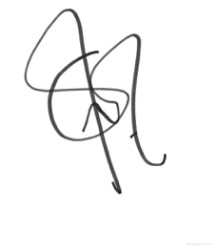
Dr. Jessica Fiolin, SpOT

