COPYRIGHT CERTIFICATION STATEMENT
Jurnal Profesi Medika : Jurnal Kedokteran dan Kesehatan

The undersigned below:
Name Author 1 : ……PUTU INDAH BUDIAPSARI.....................................................
Name Author 2 : ……I NYOMAN SUPADMA…...............................................................
Name Author 3 : ……………………………………………………...............................................................

State that the manuscript / article is entitled “…DETERMINANT FACTORS OF LOW COGNITIVE, MOTORIC AND LANGUAGE PERFORMANCE OF HIV-INFECTED CHILDREN
” belong to the publisher with the author's knowledge. Related to this, I / we transfer and give full publication rights of the manuscript / article to the publisher in accordance with copyright law regulations.

This is the statement letter I / we submit, thank you for your attention.
DENPASAR, 11/06/2022
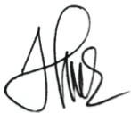
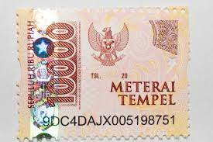
Materai stamp + Sign Author

PUTU INDAH BUDIAPSARI

