COPYRIGHT CERTIFICATION STATEMENT
Jurnal Profesi Medika : Jurnal Kedokteran dan Kesehatan

The undersigned below:
Name Author 1 : Nastiti Maharani
Name Author 2 : Gembong Satria Mahardhika
Name Author 3 : Theodore Dharma Tedjamartono

State that the manuscript / article is entitled “ERECTILE DYSFUNCTION AND COVID-19: A CASE REPORT” belong to the publisher with the author's knowledge. Related to this, I / we transfer and give full publication rights of the manuscript / article to the publisher in accordance with copyright law regulations.

This is the statement letter I / we submit, thank you for your attention.
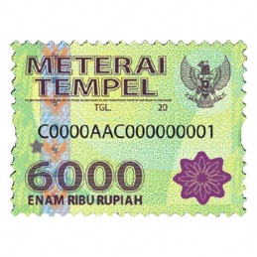
Jakarta, March 16th 2021
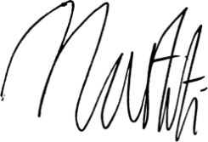

Nastiti Maharani

