Supplementary Files

CHROMOBLASTOMYCOSIS TREATMENT WITH COMBINATION THERAPY OF ITRACONAZOLE (PULSE DOSE) AND CRYOTHERAPY
Nugrohoaji Dharmawan¹, Ahmad Fiqri¹

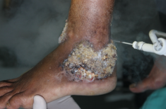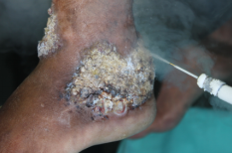
A
B
Figure 5. Cryotherapy on chromoblastomycosis with freezing time of 60 seconds/cycle

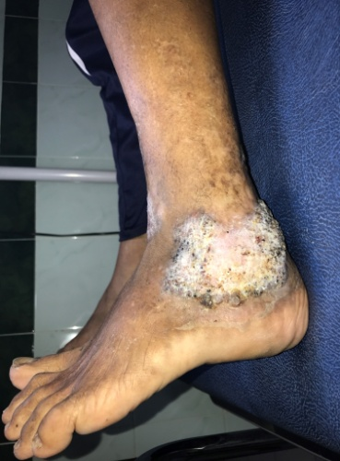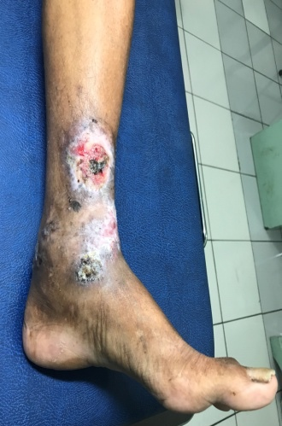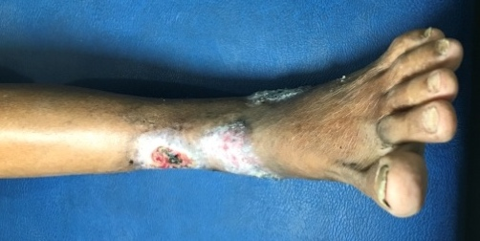
C
B
A

Figure 6. Post-cryotherapy and Itraconazole pulse dose therapy, on 2nd month

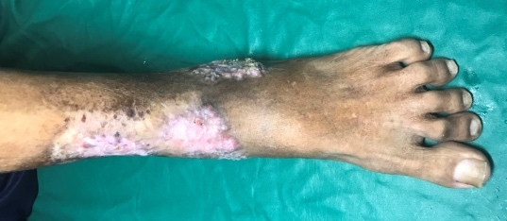
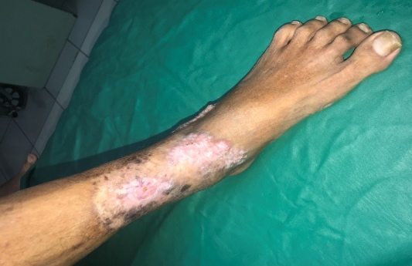
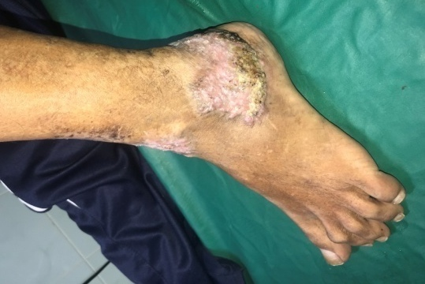

C
B
A

Figure 7. Post-cryotherapy and Itraconazole pulse dose therapy, on 3rd month

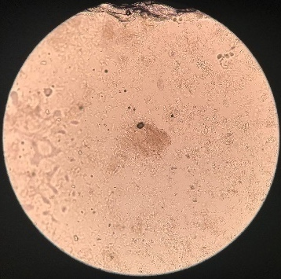

Figure 8. Examination of skin scraping with KOH 10% on the infected skin lesion post combined therapy for 3 months, finding no spore (-).

