Decreas of BCL-2 Expression by Ethanol Extract of Ocinum basilicum L. Leaves in Breast Cancer Cells

Fatimatuz Zahroh, Lina Wahyuni, Ibrahim Arifin, Devi Nisa Hidayati*

¹ Faculty of Pharmacy, Universitas Wahid Hasyim, Semarang, Indonesia

*Correspondence email : devinisahidayati@yahoo.com

ABSTRACT

Ocinum basilicum L has been shown to have cytotoxic activity against breast cancer cells in vitro. The pathway that can cause cell death can involve one of the proteins, namely BCL-2. This study aims to determine the decrease in the expression of BCL-2 protein in breast cancer cells (T47D and MCF-7) treated with the ethanol extract of Ocinum basilicum L.
Ocinum basilicum L. was extracted using the maceration method with 70% ethanol solvent. The concentration of the ethanol extract of Ocinum basilicum L. used to see the expression of BCL-2 protein in T47D and MCF-7 cells was 199 µg / ml and 388 µg / mL, respectively. Observation of BCL-2 protein expression using immunocytochemical methods against cancer cells T47D and MCF-7.
The results showed that the ethanol extract of Ocinum basilicum L was able to reduce BCL-2 protein expression in breast cancer cells (T47D and MCF-7) at concentrations of 199 µg / ml and 388 µg / mL..

Keywords: Ocinum basilicum L; BCL-2; T47D; MCF-7

INTRODUCTION
Breast cancer is still a cancer whose incidence is still quite high in the world (1). Cancer treatment efforts are always being developed, because there is no specific drug that can kill cancer cells. Current treatments still show side effects on normal cells (2). Plants are thought to have relatively lower side effects, so that natural medicine-based treatments are always being developed.
Ocimum basilicum L. is a plant that has anticancer activity against breast cancer cells (3). Ocimum basilicum contains ursolic acid active compounds that can inhibit cell proliferation (4). Ocimum basilicum is proven to contain active flavonoids, saponins, essential oils and tannins (5). Flavonoids and saponins are known to inhibit BCL-2 expression (6).

One of the antiapoptotic proteins is BCL-2, so that the expression of BCL-2 protein is expected to decrease to stimulate apoptosis. BCL-2 protein is a protein that plays a role in the regulation of apoptosis (7). Based on the above background, the researchers wanted to know the decrease in BCL-2 expression by the ethanol extract of Ocimum basilicum L. against breast cancer cells (T47D and MCF-7).

MATERIAL AND METHODS
The tools used in this study were a drying cupboard, moisture balance, a set of maceration devices, scales and rotary vacuum evaporator (Heildolph), Laminar air flow cabinet (LAF), CO2 incubator (Heraceus), microscope, 6-well plate (Nunc), Hemocytometer (Neubauer).

The materials used in this study were leaves of Ocimum basilicum L. (from Bandungan, Semarang district), 70% ethanol, cell line T47D and MCF-7 (Lab. Parasitology FK UGM), DMEM media, DMSO, primary antibodies against BCL-2. (Dako), Streptavidin, Secondary bionylated IgG antibodies, Hematoxylin, Chromogen 3,3-diaminobenzidin (DAB).
Plant determination of Ocimum basilicum L. was carried out at the Fakultas MIPA Universitas Diponegoro. Determination is done by matching plant morphology with reference books.
The making of the ethanol extract of Ocimum basilicum L: The leaves of Ocimum basilicum L. which were dry and had a moisture content <10% (14) were pollinated. The leaf powder of Ocimum basilicum L. was then carried out a maceration process for 5 days (3 days of maceration, 2 days of remaceration) using 70% ethanol solvent. Comparison of powder and solvent (1:10). The macerate and remaceration results were combined, then converted into a viscous extract using rotary vacuum evaporator (T: 50 ℃).
Immunocytochemical test concentration: The basis for using the concentration used is the IC50 value of the ethanol extract of Ocimum basilicum L. against T47D and MCF-7 cells. The IC50 values ​​obtained from previous studies on T47D and MCF-7 cells were 399.86 μg / mL and 387.76 μg / mL, respectively (3). Where in the immunocytochemical test, the concentration of the ethanol extract of Ocimum basilicum L. used was ½ IC50 (199 μg / mL on T47D cells) and IC50 (388 μg / mL on MCF-7 cells).
T47D and MCF-7 cell preparation. The cells in the cryo tube were taken from the liquid nitrogen tank followed by thawing at 37 ° C and sprayed with alcohol. The cells were transferred to a sterile conical tube in which DMEM media was present. Centrifuged for 10 minutes until visible supernatant and pellets. The supernatant was discarded, while the pellets were added with a growth medium (containing 10% FBS) of 10 mL. After homogeneous, divide into 2 tissue culture dish (TCD), at 37 ° C in a CO2 incubator. Cells are grown to confluent so that they can be used for research.
Harvesting of T47D and MCF-7 cells: The cells which were confluent and sufficient for the study were discarded and then washed with PBS. Cells attached to TCD are removed by adding trypsin-EDTA. If the cells have been released, then add DMEM media. Centrifugation of the suspension, the supernatant is discarded. The pellets are added with culture media. Count the number of cells using a hemocytometer under an inverted microscope. The cell suspension was transferred into a sterile conical tube according to the number of cells to be used for immunocytochemical testing.
Immunocytochemical test: testing was performed using T47D cell density (1x10⁵ cells / well) and MCF-7 cells (5 x 10⁴ cells / well). Treatment with different cells using different 6-well plates. Each well was planted with 1000 μL cells. Wait until the cells are attached to the coverslip and add 100 μL, then incubate for 24 hours in a CO2 incubator. After 24 hours, take the media and wash it with PBS, and add to the extract concentration that has been determined, namely for MCF-7 cells using a concentration of 388 µg / mL and T47D cells at a concentration of 199 µg / mL are incubated again for 24 hours. Followed by fixation and incubated in a freezer -4 ° C for 10 minutes. The cells that were in the coverslip were removed and placed on a 6 cm dish and washed with distilled water, then dripped with hydrogen peroxidase blocking solution (10 minutes), at room temperature, discarded. Incubated with prediluted blocking serum (10 minutes), discard. Then dripped with anti-Bcl-2 Monoclonal Primary Antibody (1:50 dilution) on T47D/ MCF-7 cells for 24 hours at 4ºC. 24 hours later, washed with PBS. The preparations were incubated in a biotinylated universal secondary antibody (10 minutes). The preparation was incubated in the streptavidin-peroxidase complex reagent (10 minutes). The preparations were incubated in DAB substrate solution (2-10 minutes), washed, and soaked in Mayer Haematoxylin (1-3 minutes) for further counterstain washing. Dip the xylol dripped with mounting media and covered with a cover preparation. Protein expression was observed under a light microscope with a magnification of 100-1000x and also performed on control cells (8).

RESULT
Plant determination is the initial step that must be carried out if a study uses natural ingredients. The purpose of the determination is to find out that the plant identity used is correct by comparing the plant morphology with reference books. From these results shows the keys of determination and states that the plant used is Ocimum basilicum L.
The leaves of Ocimum basilicum L. were carried out by changing from the form of simplicia to leaf powder to expand the surface in contact with the solvent, thereby facilitating the solubility of the compound with the solvent (15). The ethanol extract of Ocimum basilicum L. has cytotoxic activity against T47D and MCF-7 cells with IC50 values of 399.86 μg / mL and 387.76 μg / mL, respectively (3). Another study related to the cytotoxic test of the methanol extract of Ocimum basilicum L. In MCF-7 cancer cells showed an IC₅₀ of 98.51 μg / mL, this shows that the difference is possible because the solvent used is different. Methanol solvent can attract higher levels of flavonoids than ethanol solvent (13). However, from a safety point of view, ethanol solvent is less toxic than methanol. The concentration reference used was the study of the ethanol extract of Ocimum basilicum L cells T47D and MCF-7 with IC₅₀ values ​​of 399.86 μg / mL and 387.76 μg / mL (3), because the solvent and materials used came from the same place.
The immunocytochemical test is a test to see the expression of the BCL-2 protein. It has been proven that the effect of Ocimum basilicum L. ethanol extract has anticancer activity against T47D and MCF-7 cells (3). Methanol extract of Ocimum basilicum L. was shown to have cytotoxic activity against MCF-7 cells (9). Similar research on the methanol extract of Ocimum basilicum L. stated that the extract was able to stimulate the death of MCF-7 cells (4). So, it is necessary to investigate whether cell death (apoptosis) due to the treatment of Ocimum basilicum L. ethanol extract can affect and through a decrease in the antiapoptotic protein, namely BCL-2.
The immunocytochemical test at the concentration of the ethanol extract of Ocimum basilicum L. used was ½ IC₅₀ (199 μg / mL on T47D cells) and IC₅₀ (388 μg / mL on MCF-7 cells). Immunocytochemical testing was performed on MCF-7 cells because these types of cells had BCL-2 overexpression characteristics (10). BCL-2 protein is one of the anti-photosis proteins, meaning that the increase in this protein inhibits apoptosis or increases cell survival (7, 11). Immunocytochemical test results for the ethanol extract of Ocimum basilicum L. (EEOB) on T47D cells (Figure 1) and MCF-7 cells (Figure 2).
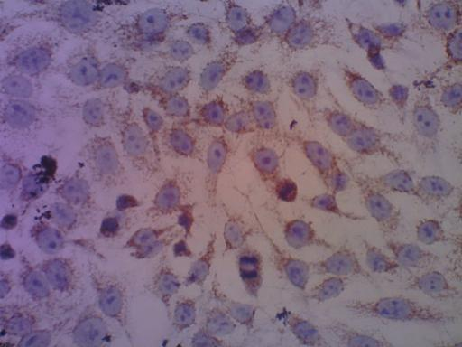
A

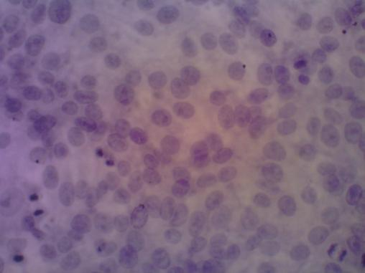
B

Figure 1. Effects of Ocimum basilicum L ethanol extract treatment on BCL-2 expression in T47D cells. Positive control of cells with anti BCL-2 (A) primary antibody staining, EEOB concentration of 199 μg / mL (B), → positive BCL-2 expression, ----> negative BCL-2 expression.

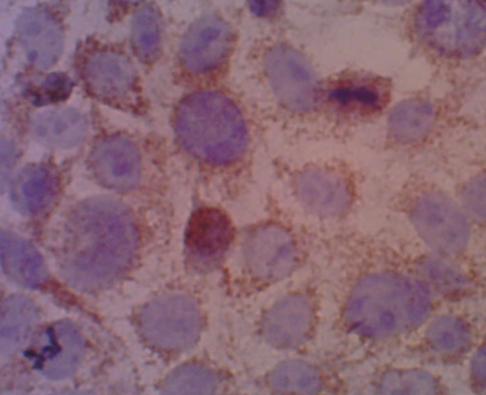
A

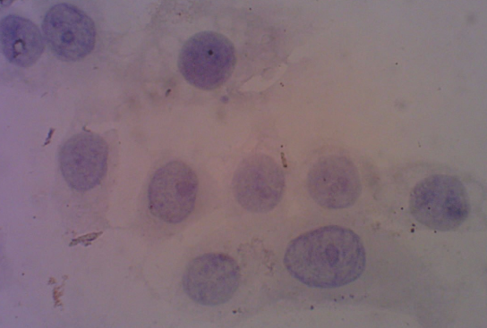
B

Figure 2. Effects of Ocimum basilicum L ethanol extract treatment on BCL-2 expression in MCF-7 cells. Positive control of cells with anti BCL-2 (A) primary antibody staining, EEOB concentration 388 μg / mL (B), → positive BCL-2 expression,
---> negative BCL-2 expression

DISCUSSION
The observation of BCL-2 protein expression was carried out by the immunocytochemical method, where the principle is that of specific antibody binding. Cells show brown when expressing protein and purple when expressing no protein. Figures 1B and 2B show that compared to 1A and 2A shows a decrease in BCL-2 expression after being treated with the ethanol extract of Ocimum basilicum L. The decreased expression of BCL-2 after EEOB treatment is visible because it shows the cell cytoplasm looks blue compared to the control which is visible. more brown. This shows that the ethanol extract of Ocimum basilicum L. can reduce BCL-2 protein expression in breast cancer cells (T47D and MCF-7).
Ocimum basilicum is proven to contain active flavonoids, saponins, essential oils and tannins (5). Flavonoids are reported to be able to stimulate apoptosis by several mechanisms, including inhibition of DNA topoisomerase I / II, decreased BCL-2 and BCL-XL, and increased expression of Bax and Bak genes (12). BCL-2 protein is one of the proteins involved in the apoptosis process (7).

CONCLUSION
The results showed that the ethanol extract of Ocinum basilicum L was able to reduce the expression of BCL-2 protein in breast cancer cells (T47D and MCF-7).

REFERENCES
- Pusat Data dan Informasi Kemenkes. (2015). Stop Kanker. Jakarta: Departemen Kesehatan
- Xu F, Wang F, Yang T, Sheng Y, Zhong T, and Chen Y. 2014, Differential Drug Resistance Acquisition to Doxorubicin and Paclitaxel in Breast Cancer Cells, Cancer Cell Internasional. 14(142): 1-13. https://doi.org/10.1186/s12935-014-0142-4
- Hidayati DN, Arifin I, Zahroh F, Wahyuni L. (2019). Efek Sitotoksik Ekstrak Etanolik Ocimum basilicum L. Pada Sel Kanker Payudara. Jurnal Pharmascience. 6(2):74-79. http://dx.doi.org/10.20527/jps.v6i2.7353
- Qamar KA, Dar A, Siddiqui BS, Kabir N, Aslam H, Ahmed S, Erum S, Habib S, and Begum S, (2010). Anticancer Activity of Ocimum basilicum and the Effect of Ursolic Acid on the Cytoskeleton of MCF-7 Human Breast Cancer Cells. Letters in Drug Design and Discovery. 7:726-736. 10.2174/1570180811007010726
- Depkes RI. (2001). Inventaris Tanaman Obat Indonesia (1) jilid 2. Jakarta: Departemen Kesehatan dan Kesejahteraan Sosial Republik Indonesia
- Raju and Rao. (2004). Diosgenin a Steroid Saponin of Trigonella Foenum Graceum (Fenugreek) Inhibits Azoxymethane Induced Aberrant Crypt Foci Fomation in F344 Rats and Induces Apoptosis in HT-29 Human Colon Cancer Cells. Cancer Epidemiology Biomarker and Prevention. 13: 1392. PMID: 15298963
- Simstein R, Burow M, Parker A, Weldon C, and Beckman B. (2003) Apoptosis, Chemoresistance, and Breast Cancer: Insights from The MCF7 Cell Model System. Exp Biol Med. 228:995–1003. DOI: 10.1177/153537020322800903
- Cancer Chemoprevention Research Center. (2009). In Vitro Test Protocol. Available at http://ccrc.farmasi.ugm.ac.id. (12 Agustus 2016).
- Al-Ali KH, Beshbishy HSE, Badry AAE, and Alkhalaf M. (2013). Cytotoxic Activity of Methanolic Extract of Mentha Longifolia and Ocimum basillicum Against Human Breast Cancer. Pakistan Journal of Biological Science. 10:1028-8880. DOI: 10.3923/pjbs.2013.1744.1750
- Weigert A, Tziepy N, Knethen A, Johann A, Schmidt H, Geisslinger G, and Brune B. (2007). Tumor Cell Apoptosis Polarizes Macrophages—Role of Sphingosine-1-Phosphate. Molecular Biology of the Cell. 18(10): 3810–3819. doi: 10.1091/mbc.E06-12-1096
- Marleen FS, Syahruddin E, Hudoyo A, Endarjo S, Hidayat H, and Suzanna E. (2008). Ekspresi protein Bcl-2 pada sediaan blok parafin jaringan kanker paru. Jakarta: Departemen Pulmonologi & Ilmu Kedokteran Respirasi FKUI
- Ren W, Qiao Z, Wang H, Zhu L, and Zhang L. (2003). Flavonoids: Promicing Anticancer Agents. Med Res Rev. 23 (4):519-534. DOI: 10.1002/med.10033
- Zulharmitta, Elrika D, dan Rivai H. (2010). Penentuan Pengaruh Jenis Pelarut Ekstraksi Terhadap Perolehan Kadar Senyawa Fenolat dan Daya Antioksidan dari Herba Meniran (Phyllanthus niruri L.,). 2 (1): 37-45.
- Depkes RI. (2000). Parameter Standar Umum Ekstrak tumbuhan Obat. Jakarta: Departemen Kesehatan Republik Indonesia
- Voight R. (1994). Buku Pelajaran Teknologi Farmasi. Diterjemahkan oleh Soendani Noerono Soewandhi. Yogyakarta: Gadjah Mada University Press

