The consequences analysis of fire and explosion scenario using ALOHA software on loading area at Company X in 2020
Salsabilla Anisah Rizky*, Fandita Tonyka Maharani, Rizki Amalia, Azizah Musliha Fitri
Public Health Department, Universitas Pembangunan Nasional Veteran Jakarta
*Corresponding author. Email: salsabillaanisah@upnvj.ac.id
ABSTRACT
Fire can obliterate the company workers end products in the fastest time, resulting in financial losses with the emergence of the potential hazard. If this happened in the Loading area, it could cause a delay to the distribution departure schedule all over Java. This study aimed to analyze fire and explosion scenarios that occur due to the diesel storage tank leakage in the Loading area at Company X with Area Location of Hazardous Armosphere (ALOHA) software. This study used a descriptive study design. The technique is data collected with literature review, direct observation, and institution data analysis. Furthermore, the data were collected also input to ALOHA software such as chemical data of isooctane, atmospheric data, and source strength to the worst scenario of leakage. That the risk area and population at risk are obtained. Threat zone from the worst scenario such as gas dispersion is 79 m, pool fire is 62 m, Boiling Liquid Expanding Vapor Explosion (BLEVE) is 457 m, and Vapor is none from the center of the fire. Furthermore, a safe distance from the diesel storage tank is as far as 457 m. The total population at risk was 39 workers in Company X and 43,846 population in Tanjung Priok Sub-District. The suggestion given is the institution manager needs to carry out socialization about hazard and impact related to fire and explosion, also the counter measures with workers and public around in loss prevention.
Keywords: ALOHA - Threat zone - Safe distance - Diesel storage tank

1. INTRODUCTION

As humans we live in uncertainty about disasters. Disasters occur due to natural, non-natural, or human factors that can cause loss of life, destruction of the environment, material loss, and psychological effects. One example of non-natural disasters is fire caused by humans due to industrial activity processes [1]. Fire events can destroy the results of the workforce carried out by the workforce in the fastest period by causing huge financial losses accompanied by potential hazards, such as injury, personal safety, damage to loss of company assets, cessation of production processes, and the environment in the area of ​​occurrence [2].
Company X is a company engaged in the activities of loading and unloading by railway mode and container using reach stackers conducted refueling diesel fuel according to the needs of reach stackers. One of the important things in refueling of the storage tank is storage for liquid or gas [3]. If an accident occurs in the loading and unloading factor, the delay in all departure schedules on the same day throughout Java Island will be postponed[4]. In relation to the field, it can cause accumulation of capacity from the stacking area to the flat carriage of the train which compresses the loading process, and vice versa in the unloading process[5].
Projecting scenarios in case of fire and explosion can be done using Arial Location of Hazardous Atmospheres (ALOHA) software through a worst case scenario study in order to obtain safe distance and threat zone. ALOHA functions to solve problems in a responsive manner and presents them in the form of graphs that are easy to understand in emergency response planning conditions [7]. Therefore, using ALOHA software is useful for analyzing the frequency and consequences of fire and explosion so that they can be used as a reference in recommendations for disaster mitigation measures[8]. ALOHA software makes it easy to use with integrated Google Earth software so that research locations at risk can be identified directly.
Seeing the size of the cases and the impact of fires and explosions on the storage tank, it is necessary to analyze the scenario for the diesel fuel storage tank at Company X in loading and unloading area. Thus, the aims of this study is to analyze consequence of fire and explosion scenario that occur due to the diesel storage tank leakage using ALOHA software on loading area at Company X in 2020.

2. METHODS

This research is a descriptive study. In this study, modeling of gas dispersion, pool fire, Boiling Liquid Expanding Vapor Explasion ( BLEVE ) , and Vapor Cloud Explosion (VCE) explosion were made using ALOHA software projected on an electronic map or Google Earth software.
ALOHA parameters consist of location data, chemical data, atmospheric data, and leak source data. The data collected when the research was carried out based on the source of the information in the form of primary data and secondary data. Primary data obtained from direct observation to the research location to determine environmental conditions and the population at risk around the loading and unloading area at Company X in threat zone. Meanwhile, secondary data sources were obtained by researchers through document review, literature studies, and government publications. Secondary data obtained came from literature studies and review of company documents, including chemical data and leakage source data. Chemical data obtained through secondary data in the chemical library is available in ALOHA software. Leakage source data obtained from company data and literature studies. The atmospheric condition data is obtained from government publications through the website of the Meteorology, Climatology and Geophysics Agency (BMKG).
Modeling using ALOHA will produce threat zone from the kinds of failures that occur from the scenario when simulating at or the worst case scenario. Threat zone from these models will be analyzed for the number of worker population and public at risk. After obtaining the results of threat zone analysis from each model using ALOHA software, it can provide an overview regarding safe distance.

3. RESULTS AND DISCUSSION

3.1 Data for fire and explosion consequence analysis using ALOHA software

3.1.1 Location data

The research location is Company X in Tanjung Priok Sub-District with coordinates obtained from Google Earth are 6º06'43.11 " South, 106º52'34.87" East, and an elevation of 3 meters above sea level .
By using Google Earth software, measure the closest distance of each area to the location of the diesel fuel storage tank at Company X. The closest distance from diesel fuel storage tank at Company X to Tanjung Priok Port is approximately 429 meters. The closest distance from diesel fuel storage tank at Company X to Kampung Bahari Street approximately 66 meters. The closest distance from diesel fuel storage tank at Company X to Tanjung Priok Train Station is approximately 440 meters.

3.1.2 Chemical data

The chemical contained in the storage tank is isooctan. Isooctan data from the chemical library in ALOHA software with molecular weight of 114.23 grams/mol, Poly Aluminum Chloride (PAC)-1 230 ppm, PAC-2 5000 ppm, PAC-3 5000 ppm, Lower Explosive Limit (LEL) 9500 atm, Upper Explosive Limit (UEL) 60000 atm, vapor pressure 0.082 atm, boiling point 99.2 ℃, and ambient saturation concentration 8.22%.

3.1.3 Atmospheric data

The atmospheric data used is the highest condition that has occurred in Tanjung Priok Sub-District used in the worst case scenario. From the atmospheric data obtained wind speed of 32 kilometers/hour from the west (measurement height of 10 meters), open area, air temperature of 30 ℃, no intervention, and air humidity of 76%.

3.1.4 The source data of the leak

The object of research is the storage tank of diesel fuel in the loading and unloading area at Company X. The storage tank has a horizontal cylindrical type, the tank length is 4.6 meters, the diameter is 1.66 meters, the tank volume is 10000, and the empty weight is 5490 kilograms.

3.2 Consequence analysis of fire and explosion using ALOHA software

3.2.1 Consequences analysis of isooctan dispersion

Based on the results of the ALOHA simulation, the isooctan dispersion occurred for 12 minutes with total of 622 kilograms isoocatn released into the air with an average release speed of 58.6 kg/minute. The isooctan chemical is released as liquid and forms a pool that evaporates. The puddles spread over diameter of 14.5 meter. Based on the results of the threat zone, the Level of Concern (LOC) value in this case is PAC, the concentration of isooctan in the yellow zone is 230 ppm in 60 seconds with a distance of 79 meters has the potential to cause death, the orange zone is 830 ppm with a distance of less than 11 meters has the potential to cause 2nd degree burns, and the red zone of 5000 ppm with a distance of less than 10 meters has the potential to cause pain .
In this modeling, heavy gas is used because the gas released into the air is heavier than the air, so its dispersion behavior will be different from that of neutral light gas. Heavy gas will move downhill because it is heavier than the surrounding air. Like cloud of gas moving in the direction of the wind, gravity causes the gas to spread out. Furthermore, the gas cloud will thin out and the density of the gas will be almost the same as air dispersion properties of the neutral light gas. A gas that has molecular weight greater than air (the average molecular weight of air is 29 kilograms/kilomol) will form heavy gas cloud if there is sufficent gas release [9].
Gas dispersion is the occurrence of natural gas occurring in the gas phase because of the leakage of a component that is under pressure and no source of ignition in the surrounding facilities or infrastructure. The resulting gas is not toxic but can cause a slight asphyxiation if inhaled by humans. Mild asfiction is the removal of oxygen to body tissues that are disturbed due to the function of the lungs, blood vessels, or body tissues [10].

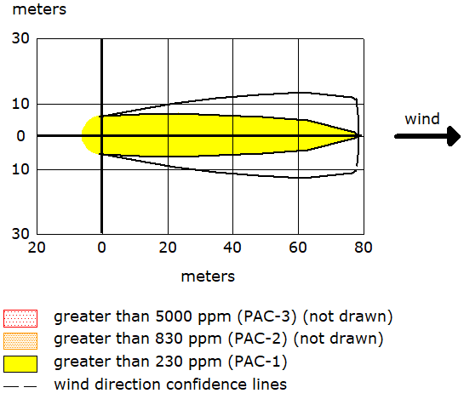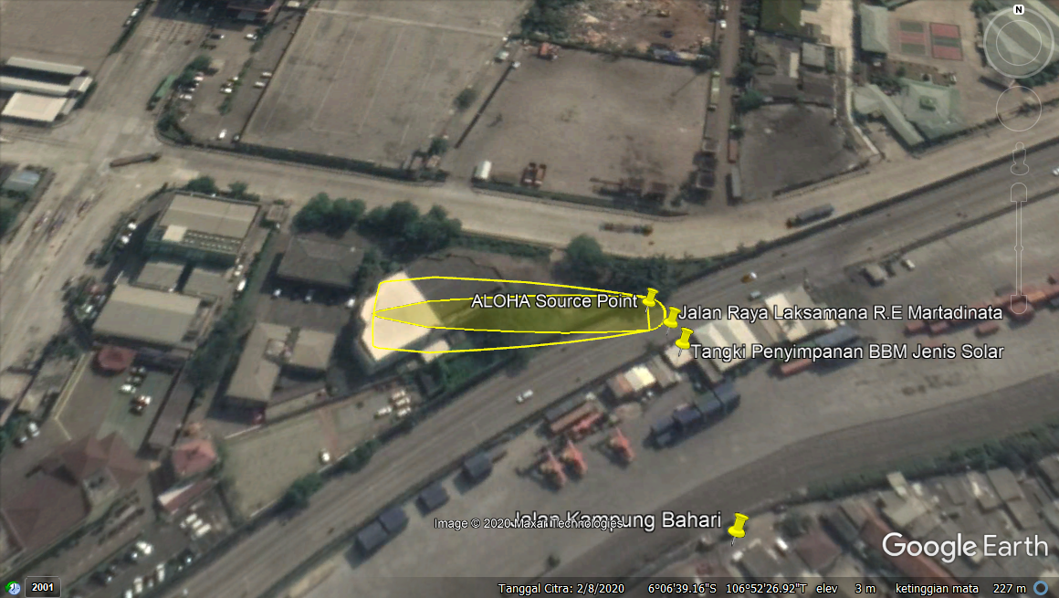

Fig. 1 Projecting output of isooctan dipersion modeling

3.2.2 Consequence analysis of pool fire

Leakage of the diesel fuel storage tank when the isooktan chemical is released as a liquid and forms a pool that evaporates causing pool fire. Based on the results of the ALOHA simulation, pool fire occurred for 1 minute with a total of 622 kilograms of isooktan burned at a rate of 671 kilograms/minute. The maximum length of flame reaches 19 meters. The puddle spreads out over a diameter of 11.5 meters. ALOHA recommends the LOC value related to pool fire in the yellow zone of 2.0 kW/meter in 60 seconds with a distance up to 62 meters has the potential to cause death, the orange zone of 5.0 kW/meter in 60 seconds with a distance up to 46 meters has the potential causes 2nd degree burns, and the red zone of 2.0 kW/ meter in 60 seconds with a distance up to 62 meters has the potential to cause pain.
Pool fire is the flame horizontally on the surface of the fuel. The main thing to prevent is fuel spills [11]. These events can occur when flammable liquids or fuel spills form a pool on the ground and catch fire. The main danger that exists is thermal radiation, besides that it can be in the form of smoke, toxic by products of fire, and fire or explosion in the surrounding area [5].
Pool fire modeling is determined not only by the chemical burned but also by local weather conditions where the fire occurred. Weather conditions affect the speed of diesel evaporation, evaporation has the potential to cause poison and have the potential to cause fire. If the vapor is triggered by an ignition source, it will quickly grab a puddle of diesel from the steam. Based on the fire tetrahedron theory, the vapor combustion reaction will release energy that can break other carbon chains, causing a chain reaction that will trigger greater release of energy or more intense fire [12].

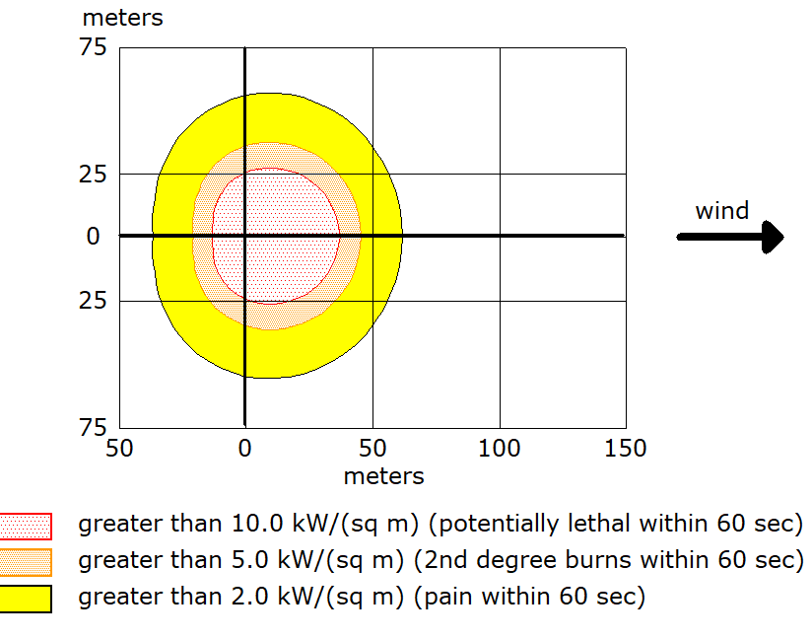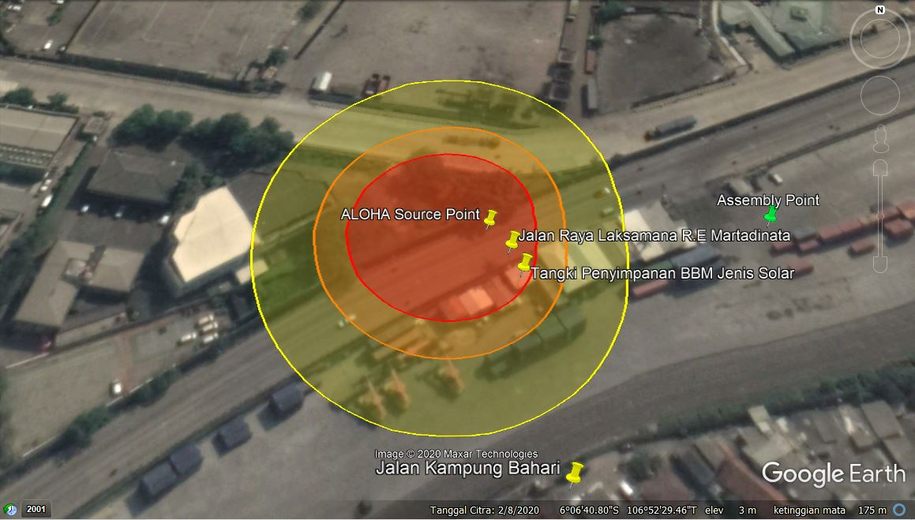

Fig. 2 Projecting output of pool fire modeling

3.2.3 Consequence analysis of BLEVE

Diesel fuel storage tank with the scenario of the tank mass being filled with a fireball by 80%, BLEVE in the form of a fireball with a diameter 95 meters for 7 seconds. The length of the fire is 41 meters. ALOHA recommends the LOC value related to the BLEVE scenario in the yellow zone of 2.0 kW/m in 60 seconds with a distance of 457 meters has the potential to cause death, the orange zone of 5.0 kW/m in 60 seconds with a distance up to 293 meters have the potential to cause 2nd degree burns, and the red zone 2.0 kW/m in 6 0seconds with a distance of 208 meters has the potential to cause pain.
BLEVE will arise because the tank can not withstand external heat. This external heat can cause high temperature in the tank so that the liquid in the tank will evaporate and when the tank can not hold it optimally, the tank will explode[13]. Evaporation that takes place quickly causes the accumulation of flammable vapors in the tank which has the potential to cause an explosion of great strength [14]. The storage tank which is exposed to continuous radiation and its vapor pressure continuously pressing on the wall will cause the release of a large enough fireball [15].
With a distance 457 meters from the fireball, it will have an impact on loading and unloading activities, safety, and other effects such as exposure to pressurized heat which has the potential to damage buildings or injure humans. BLEVE can cause the release of large amounts of material. If the materials explosive, it will cause a vapor cloud explosion [16].

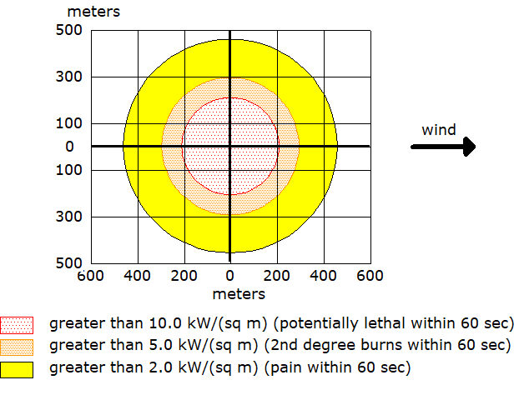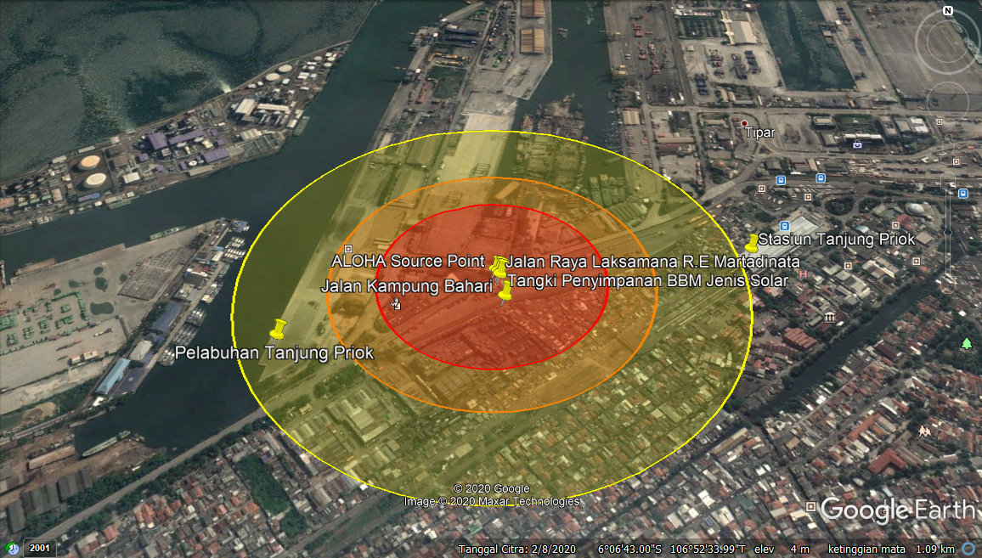

Fig. 3 Projecting output of BLEVE modeling

3.2.4 Consequence analysis of VCE

The leak of the diesel fuel storage tank caused VCE. In this modeling, VCE occurs because the steam cloud is filled. Based on the results of the ALOHA simulation, the release of isooctan occurred for 12 minutes with a total of 622 kg isooctan released into the air with maximum speed of 58.6 kg/minute. The isooctan chemical is released as liquid and forms pool that evaporates. The puddle spreads out over a diameter of 14.5 m. ALOHA recommends the LOC value with burst wave pressure in the VCE scenario in the yellow zone 1.0 psi, the orange zone 3.5 psi, and the red zone 8.0 psi. After projecting the location of the diesel fuel storage tank, it can be seen that no explosion occurred because no part of the cloud was above the LEL at any time.
When chemicals are released into the atmosphere, they form vapor cloud which disperses following the direction of the wind. When the vapor cloud meets a source of ignition, part of the cloud will burn which is in the flammability range between LEL and UEL. So that it can quickly result in the emergence of explosive pressures in several vapor cloud situations whose severity corresponds to chemicals, the size of the clouds formed when they are lit, the type of ignition, and the density of the vapor cloud. The main hazards in VCE are overpressure and dangerous building remains [5]. The source of ignition in this modeling comes from spark or flame.
Overpressure can damage everything around it to form dangerous debris. If the pressure wave is great force, it can also throw human at nearby buildings or trees. This explosion wave is also capable of damaging and flattening buildings which in turn will injure or kill the people inside. Sudden changes in pressure can also exert pressure on the ears and lungs. The closer a person is to the source of the explosion, the more severe will be impact [5].

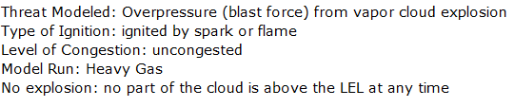

Fig. 4 Output of VCE modeling

3.2.5 Safe distance of diesel fuel storage tank at Company X

After obtaining the threat zone analysis results from each model using ALOHA software, it can provide an overview regarding safe distance of diesel fuel storage tank at Company X. The safety distance is grouped into three in the red zone with a distance of 0-79 meters, the yellow zone with a distance of 80-457 meters, and a green zone or safe zone after 457 meters. The results of the safe zone radius using ALOHA software is after 457 meters from the diesel fuel storage tank at Company X. The distance of 0-457 meters is the area of ​​Tanjung Priok Sub-District.

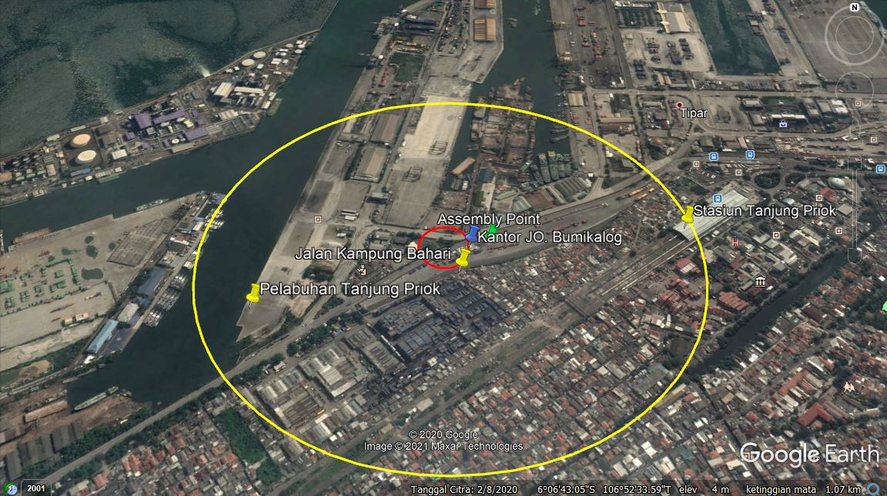

Fig. 5 Safe distance of diesel fuel storage tank at Company X

Determining safe distance for the explosion of single diesel fuel storage tank at Company X is a disaster management effort. Disaster management is an ongoing process to prevent, mitigate, prepare for emergency response, and recover from incidents that threaten life, objects, production processes or the environment [17]. One of the ways to do of disaster management is to determine fire and explosion safe areas, which are used to mitigate disasters that may arise. The mitigation concept involved in determining area to reduce the severity or impact of an emergency.
Designation of safe areas can be used to determine gathering points and safe evacuation routes of fire and explosion. In addition, the design or layout of the building can be estimated so it does not cause a series of fire or other hazards that may arise due to a fuel tank fire stockpile [12].
Based on NFPA 30, safe distance for storage tanks is ≥ 50 feet or 15 meters [18]. This is not appropriate because of the distance between the diesel fuel storage tanks at Company X to the nearest facility such as prayer room less than 5 meters. The storage tank is installed with a safety fence with a distance of less than 5 meters, calculated from the storage tank, has not reached a distance of 15 meters from the storage tank, and there is no sign of prohibition of entry for unauthorized people. This distance is not in line with the standards in Article 28 Paragraph 1 of the Regulation of the Minister of Manpower of the Republic of Indonesia Number 37 of 2016 concerning Occupational Safety and Health of Pressure Vessels and Storage Tanks, which is at least 25 meters and the installation of a sign prohibited from entering. Maintenance efforts on the tank are carried out every month to prevent corrosion by cleaning the tank to the inside of the tank. The outside of the paint storage tank is in good shape.
Total of workers in Company X are 39 workers. The population in the Tanjung Priok Sub-District area are 43,846 residents [19]. This indicates that there will be a total of 43,885 at risk being affected by potential hazards in the event of fire.

5. CONCLUSION

The occurrence of fires and explosions with scenario modeling using ALOHA software resulted in modeling of isooktan dispersion, fire pool, BLEVE, and VCE. The results of the consequence analysis if gas dispersion occurs at a range of 79 meters . The results of the consequence analysis if a pool fire occurs in the red zone, the orange zone, and the yellow zone, namely 37 m, 46 m, and 62 m from the center of the fire. The results of the consequence analysis in the event of an explosion in the form of a fireball in the BLEVE modeling scenario are 80% filled in the red zone, the orange zone, and the yellow zone, namely 208 m, 293 m, and 457 m from the center of the explosion. In addition, the VCE projection found that there was no explosion. The results of the safe distance mapping are 0-79 meters (red zone), 80-457 meters (yellow zone), and after 457 meters (green zone or safe zone). It is hoped that in the future it can be used as a source of data for further research and further research is carried out based on the location, chemicals, and different sources of leakage.

ACKNOWLEDGEMENT

This research is part of the disertation of the first author. Profound gratitude is extended to Company X for authorized and providing data of the research.

REFERENCES

- Ramli S. (2010) Practical Direction Fire Management. K3 Management Series 04. Dian Rakyat, Jakarta.
- Anggraeni AS, Ashari ML, Kusuma GE (2017) Analysis of Fire Risk Assessment and Active Fire Protection Design On Workshop Area of Fabrication Construction Service Compan. Proceeding 1st Conference on Safety Engineering and ITS Application. 1(1): 255-261. https://journal.ppns.ac.id/index.php/seminarK3PPNS/article/view/106/65. Accessed on 8 December 2020.
- Alfons G, Suyadi D (2018) Analysis of Unloading Factor as The Cause of Delay In Train Deparature at Pasoso Tanjung Priok Station PT. Logistic Railway. Logistic D III Transportation UNJ 11(2): 14-17. http://journal.unj.ac.id/unj/index.php/logistik/article/view/17679. Accessed on 2 December 2020.
- Pullarcot S (2015) Above Ground Storage Tanks Practical Guide to Construction, Inspection, and Testing. Taylor and Francis Group, Florida. https://doi.org/10.1201/b18505
- Pratama FA, Mulyono T (2019) Stacking Field Performance at Station Warehous PT. Logistic Railway. Logistic D III Transportation UNJ 12(2): 9-13. https://doi.org/10.21009/logistik.v12i2.17646
- NOAA, EPA US (2007) ALOHA The CAMEO Software System: User’s Manual.
- Da Silva Rodrigues AJ, Da Silva MHLF, De Farias DO, Teixeira MM, De Brito Rocha MF, Lins GB, Neto JDSC (2017) Risk Reliability Analysis, Resulting From Explosions In Petrochemical Industries: A Case Study Using ALOHA Software. 12th Iberian Conference on Information Systems and Technologies (CISTI): 1-6. https://doi.org/10.23919/CISTI.2017.7975733
- Abdima G (2011) Analysis of Chlorin Deployment Consequences Using ALOHA Software In Container of A Ton Chlorine Leakage at PT Pupuk Kijang Cikampek. Universitas Indonesia. http://www.digilib.ui.ac.id/detail?id=20440941&lokasi=lokal. Accessed on 2 December 2020.
- Munir M (2015) Analyze of Fire Risk Process Air Liquefaction at FLNG. Institut Teknologi Sepuluh November. http://repository.its.ac.id/id/eprint/41808. Accessed on 2 December 2020.
- Steinhaus T, Welch S, Carvel RO, Torero JL (2007) Large-Scale Pool Fires. Thermal Sciences 11(2): 101-118. https://doi.org/10.2298/TSCI0702101S
- Davlesthina TA (1998) Fire and Explosion Hazard Handbook of Industrial Chemical. Noyes Publications, New Jersey.
- Muradi M (2015) Analyze of Fire Risk Process Air Liquefaction. Institut Teknologi Sepuluh November. http://repository.its.ac.id/id/eprint/41808. Accessed on 2 December 2020.
- Firdaussyah AT (2012) Analysis of Fire Modeling at Fuel Storage Tank PT. McDermott Indonesia. Universitas Airlangga. http://repository.unair.ac.id/id/eprint/23668. Accessed on 2 December 2020.
- Hughes PEF (2003) Introduction to Health and Safety at Work: The Handbook for the NEBOSH National General. Oxford: Butterwoth-Heinemann.
- Crowl DA, Loavar JF (2002) Chemical Process Safety Fundamental With Application (Second Edition). Prentice Hall PTR, New Jersey. http://repository.unej.ac.id/handle/123456789/80969. Accessed on 8 December 2020.
- Agency NFP (2007) NFPA 1600: Standard on Disaster/Emergency Management and Business Continuity Program. 2013 Edition. NFPA, Massachusetts.
- Hardiyansyah F, (2017) Difference in Efficienct of Variations in Sand Weight and Air Pressure in The Tube of Light Fire Extingusiher as Fire Extingusiher Class B. Universitas Jember.
- North CSAJ (2020) The Centeral Statistical Agency for The City of North Jakarta in Figures 2020. https://jakutkota.bps.go.id/publication/download.html?nrbvfeve=NmQxMjkwMTdlY2QxODljYzRlMzhlOWZl&xzmn=aHR0cHM6Ly9qYWt1dGtvdGEuYnBzLmdvLmlkL3B1YmxpY2F0aW9uLzIwMjAvMDQvMjcvNmQxMjkwMTdlY2QxODljYzRlMzhlOWZlL2tvdGEtamFrYXJ0YS11dGFyYS1kYWxhbS1hbmdrYS0yMDIwLmh0bWw%3D&twoadfnoarfeauf=MjAyMS0wMS0yOCAyMzo0OTowMw%3D%3D. Accessed on 28 January 2021.

